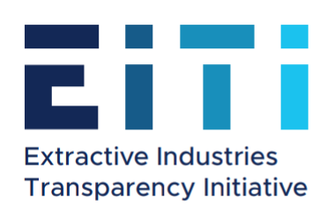

EXTRACTIVE INDUSTRIES TRANSPARENCY INITIATIVE ANNUAL PROGRESS REPORT 2018

28 June 2019
Yerevan
Contents
1. General Appraisal of the Annual Performance 3
2. Appraisal of the Performance of the Targets and Activities Set by the 2018 EITI Work Plan of Armenia 7
3. Appraisal of Performance of the EITI Requirements 28
4. The Strengths and Weaknesses Indentified During the EITI Implementation Process 34
5. Total Implementation Costs 37
6. Details of the Members of the Multi-Stakeholder Group During the Reporting Period 50
7. Questionnaires Completed by the Civil Society And Extractive Companies Constituencies of the RA EITI MSG 52
8. Annexes 61

General Appraisal of the Annual Performance
Extractive Industries Transparency Initiative (EITI) is a world standard which promotes the open and accountable management of natural resources. To achieve this objective, transparency and accountability by organizations and government agencies involved in the extractives sector (oil, gas and metals) is promoted through disclosing for the citizens the total payments made by the companies to the state and community budgets and drawing an independent comparison with the government announced revenues.
The Multi-Stakeholder Group (MSG) of the Republic of Armenia has been authorized by the Government of the Republic of Armenia to oversee the implementation of the EITI. The MSG of the EITI of Armenia comprises the representatives of the Government, mining companies and civil society. The total number of the EITI MSG members is 15, including six representatives from government agencies, four representatives from mining companies, four representatives from the civil society and one representative from academia, as well as one alternate member from the government constituency and four alternate members from the constituency of the extractive companies։ Tigran Avinyan, Deputy Prime Minister, has been the acting Chair of the MSG since 2019. The Initiative is considered to be a unique platform for trilateral cooperation in Armenia, where the stakeholders serve best the interests of the country through joint activities.
The new government formed after the revolution in Armenia in the spring of 2018 also attached importance to the implementation of the EITI Standard in Armenia, particularly in terms of fighting corruption, and committed to continue the systemic institutional and legal reforms, emphasising as an important breakthrough the preparation of the 2018 First EITI National Report, as well as elaboration of draft laws which would ensure the disclosure of beneficial ownership and the development of a public register. Changes were made to the composition of the EITI MSG. The Decree of the RA Prime Minister dated 16 July 2018 approved EITI Armenia MSGʼs new composition and appointed Ararat Mirzoyan, First Deputy Prime Minister, Chair. In 2018 the implementation of the Extractive Industries Transparency Initiative (EITI) in the Republic of Armenia were mainly focused on developing the 2018 EITI Report, conducting the Scoping Study and relevant analyses, designing the reporting templates for government agencies and extractive companies and granting them a legal status. Within the framework of the EITI, a package of draft laws was elaborated and approved on 21 March 2018. The package of the RA laws “On Making Amendments to the Mining Code of the Republic of Armenia”, “On Making Amendments to the Administrative Offences Code of the Republic of Armenia” and “On Making an Amendment to the Tax Code of the Republic Of Armenia” was elaborated which was considered by the National Assembly according to the procedure established for draft laws considered urgent and adopted on 21 March 2018. The legislative changes are aimed at enshrining publication of information on the mining sector, specified by the EITI Standard, as a mandatory requirement in the legislation.
In accordance with the requirements of the legal acts adopted within the scope of compliance with the EITI, the Ministry of Energy Infrastructures and Natural Resources published the mining contracts entered into with the metallic mineral extractive entities, as well as the information regarding the activities related to extraction of minerals and mining exploration of the mineral resources for the purpose of extracting minerals.
RA Government Decree N 666-N “On Establishing the Procedure, Time Frames and Templates for Publishing Information Regarding the Activities Related to Extraction of Minerals and Geological Exploration of the Mineral Resources for the Purpose of Extracting Minerals, the Procedure, Time Frames and Templates for Public Reporting on the Activities of the Mining Companies Holding a Permit for Metallic Mineral Extraction, and the List of Government Agencies” was issued on 8 June 2018.
In 2018 an electronic system was developed and launched for online public reporting by the extractive entities and government agencies for the EITI Report, which was a big step towards the systematic disclosure of sectoral data. A combined meeting and training was conducted for the reporting entities, during which procedures for public reporting and the guidebook for using the electronic system were presented. The reports for the EITI Armenia report and all of the reports by the mining companies and government agencies were submitted through the reporting portal (reports.eiti.am).
At the MSG meeting held on 27 March 2018 it was decided to submit a request to the International Board of EITI on the extension of the reporting deadline by 2.5 months, in view of the fact that the time frame planned for developing the EITI report was not sufficient for quality work, while an extension would allow to introduce and, for the very first report, use an innovative tool, i.e an online reporting platform. Respecting the request by the EITI Armenia MSG, a decision was passed at the meeting of the International Board of EITI in Berlin between 27 and 30 June 2018 to satisfy Armeniaʼs request and extend the reporting deadline for Armeniaʼs 2018 National EITI Report to 9 March 2019. Pursuant to the decision of the EITI Board meeting on 9 March 2017, validation will commence within two and a half years of becoming a candidate (09.09.2019).
For the purpose of designing the first EITI Report, in June 2018 “Ernst and Young” CJSC auditing firm was selected through competition as the Independent Administrator. Cooperating with all of the stakeholders, i.e. the government agencies responsible for the draft report, Multi-Stakeholder Group, the Secretariat and other interested organisations and individuals, and taking into account their considerations, “Ernst and Young” developed the first EITI Report for the financial years 2016 and 2017.
At the meeting of EITI Armenia multi-stakeholder group on 5 December 2018, the MSG approved the draft first EITI Armenia National Report, on condition that the report addresses the submitted recommendations and considerations. At the meeting the MSG also approved EITIʼs 2019-2020 national priorities, EITIʼs 2019-2020 Work Plan and the EITI Roadmap for the implementation of responsible mining practices.
During the reporting period, activities were also carried out towards publishing the online register of beneficial owners by 1 January 2020. The register will be publicly available. The Beneficial Ownership Disclosure Roadmap, published in December 2017, was transformed into a Government Protocol Decree, and an Inter-Agency Working Group on Beneficial Ownership Disclosure was created by Decision 297-A of the RA Prime Minister, dated 27 March. Members from the three constituencies of MSG and representatives of state authorized bodies were involved in the group. The Working Group was headed by the Deputy Minister of Energy Infrastructure and Natural Resources, EITI MSG Member, Vardan Gevorgyan. The Working Group developed a package of draft laws regulating the legal issues related to disclosure of the beneficial owners of the companies operating in the metal mining sector of Armenia. During the reporting period, the package of draft laws regulating the legal issues related to the disclosure of the beneficial owners of the companies was approved at the RA Government meeting and submitted to the National Assembly.
In line with the deadline set for Armenia by the EITI Board, during the reporting period the MSG approved and published the 2017 EITI Annual Progress Report in June 2018. The Report summarised the activities towards the implementation of EITI in Armenia during 2017.
The changes in the composition of the Government during the reporting year resulted in changes in the composition of the MSG. The composition of the Multi-Stakeholder Group was approved by Decision N 960-A of the Prime Minister of the RA, dated 16 July 2018. Ararat Mirzoyan, First Deputy Prime Minister, was appointed Chair of the RA EITI MSG. Ararat Mirzoyanʼs powers were terminated in December 2018 in connection with his becoming Speaker of the National Assembly of the Republic of Armenia.
During the reporting period, a number of activities approved by the EITI Armenia Work Plan were carried out, namely, public awareness raising, design of the official website of EITI Armenia, development and English translation of the 2017 EITI Annual Progress Report and other documents, cooperation with the International Secretariat and international partners of EITI, preparations for the activities planned for early 2019.

During the reporting year the key activities undertaken by the MSG were aimed at:
- Development and approval of the Scoping Study for the purpose of designing the EITI Report;
- Development and approval of EITI First National Report;
- For EITI compliance, drafting laws of the RA aimed at enshrining the mandatory requirement in the legislation for publication of the complete information on the Permits Register as required by the EITI Standard in the mining sector and as specified by the EITI Standard, as well as the disaggregated data for all the taxes paid and payments made by the mining companies to the national and local budgets and the authorized bodies.
- Implementation of the activities of the Beneficial Ownership Disclosure Roadmap of metal mining companies of the Republic of Armenia which would result in that the names of beneficial owners of the companies operating in the metal mining sector of the RA will be known to the public as of 1 January 2020;
- Public awareness raising, especially attaching importance to the development and launch of the official website of EITI Armenia with UNDP support;
- Ensuring access to key EITI documentation for the public at large; and
- Work with international partners. During the reporting year the EITI implementation process in Armenia was assisted by the World Bank, the British Embassy to Armenia, UNDP Armenia and the German Agency for International Cooperation (GIZ). The project “Support for the Global Extractive Industries Transparency Initiative (EITI) in Armenia, Georgia and Ukraine” by GIZ was approved by the “Public Administration Reform and Modernization in the Eastern Partnership” initiative of the Federal Republic of Germany.
- Cooperation with the EITI International Secretariat.
During the reporting year the development of the institutional bases for the EITI implementation process in Armenia, raising the financial guarantees, forming the “EITI community” through the engagement of all the stakeholders and building the capacity of the MSG members and the other representatives were continued.

Appraisal of the Performance of the Targets and Activities Set by the 2018 EITI Work Plan of Armenia
ACCOMPLISHED ACTIVITIES ACCORDING TO THE
2018 WORK PLAN OF EITI ARMENIA

Objective | Ensuring accessible and timely information
ACTIVITY 2. Creating the RA EITI website | Outcome/output and timeline | Implementation status | Responsible parties
 | Outcomes/outputs: RA EITI website; RA EITI website, databases, database processing tools for providing online access to information, conducting inquiries, free information viewing functionality, creation of an online reporting portal  Timeline: June 2018  Implementation: 2018 | Implemented during the reporting period, with delay from the deadline set by the Work Plan. After that carried on activities on the improvement of developed tools and trubleshooting, creation of filters based on tools and data base in the reports.eiti.am system | RA Prime Minister’s Office/ARM-EITI Secretariat, Helix Consulting LLC
Activity 3. Ongoing website support | Outcome/output and timeline | Implementation status | Responsible parties
 | Outcomes/outputs: ongoing website support, trubleshooting  Timeline: Ongoing | Ongoing | RA Prime Minister’s Office/ARM-EITI Secretariat, Helix Consulting LLC
Activity 4. Posting appropriate information in the EITI website (reports, videos, protocols) | Outcome/output and timeline | Implementation status | Responsible parties
 | Outcomes/outputs: Reports, videos, protocols published in the website  Timeline: Ongoing | Ongoing | MSG, RA Prime Minister’s Office/ARM-EITI Secretariat
Activity 5. Disclosure and publication of information on the mining sector in an easily understood language, preparation of social advertising | Outcome/output and timeline | Implementation status | Responsible parties
 | Outcomes/outputs: Information sheets, infograms, EITI report, MSG annual report, information video-clips  Timeline: Ongoing | Ongoing | MSG, RA Prime Minister’s Office/ARM-EITI Secretariat
Activity 6. Awareness campaign on mining sector and EITI and their elucidation via social media (YouTube, Twitter, Facebook, etc.) | Outcome/output and timeline | Implementation status | Responsible parties
 | Outcomes/outputs: Information about mining and EITI published in social media  Timeline: Ongoing | Ongoing | MSG, RA Prime Minister’s Office/ARM-EITI Secretariat
Activity 7. Development of communication strategy | Outcome/output and timeline | Implementation status | Responsible parties
 | Outcomes/outputs: Draft communication strategy  Timeline: April 2018 | Accomplished | MSG, Prime Minister's Staff/ARM-EITI Secretariat, expert
Activity 8. Approval of communication strategy | Outcome/output and timeline | Implementation status | Responsible parties
 | Outcomes/outputs: Communication strategy  Timeline: May 2018  Implementation: July 2018 | Implemented during the reporting period, with delay from the deadline set by the Work Plan, because MSG meeting was not held after the submission of final version of the communication strategy. | MSG
Activity 9. Implementation of awareness raising measures | Outcome/output and timeline | Implementation status | Responsible parties
 | Outcomes/outputs: Round tables, meetings, including with representatives of affected communities, meetings with educational institutions  Timeline: Ongoing | Ongoing | MSG, RA Prime Minister’s Office/ARM-EITI Secretariat
Activity 10. Official presentation of EITI report / conference | Outcome/output and timeline | Implementation status | Responsible parties
 | Outcomes/outputs: EITI conference  Timeline: October 2018  Implementation: January 2019 | EITI Conference was held after publishing EITI National Report on 30 January,2019 according with the 2019-2020 EITI Work plan. | MSG, RA Prime Minister’s Office/ARM-EITI Secretariat

DESCRIPTION OF THE COURSE OF IMPLEMENTATION OF THE OBJECTIVE
Activity 2. Creating the RA EITI website
The tender implemented within the framework of cooperation with UNDP Armenia resulted in the selection of “Helix Consulting” LLC as the company to develop the official website of EITI Armenia. During the reporting period the website development activities proceeded.
The Secretariat actively collaborated with “Helix Consulting”. Five meetings were held, resulting in the finalisation and approval of the website design and structure (section, subsection, and online reporting system), as well as the issues related to the types of information stored in the respective units and open data policy. “Helix Consulting” company conducted a website content management training for the Secretariat staff. Additionally, after completing the work on the design of the website and the approval of the reporting forms by the MSG, the electronic reporting system for online reporting by the companies and government agencies was developed. In order to increase the effectiveness of use of the system, the Secretariat paid special attention to excluding, to the extent possible, any technical errors, omissions and defects during the completion and submission of the EITI public reports through software solutions.
“Helix Consulting” LLC carried out the following works: launching the electronic reporting system for public reports; testing of the system; correction of the issues arising in the process of submitting reports by the users; and creation of tools for submitting the data formed as a result of the public reports submitted by the mining companies and government agencies, to make the data available to the public in a more accessible way and to provide broader opportunities for their use. During the reporting period, the responsible staff of “Helix Consulting” LLC, the Independent Administrator and the EITI Secretariat of Armenia provided consultancy to the representatives of the mining companies and government agencies which report on a daily basis, on how to register in the system, complete the public reports, sign and submit them.
During the reporting period, “Helix Consulting” LLC, the Independent Administrator and the EITI Secretariat of Armenia held a series of meetings in order to approve the formats for presenting the databases on the EITI website, as well as the structure of the tools enabling to make the data presented through the public reports publicly accessible using various filters. As a result, the Secretariat approved the design of the relevant pages, formulas were developed for generating tables with the necessary information from the database using filters, the filters were developed, and the systems were launched.
Activity 4. Posting appropriate information on the EITI website (reports, videos, minutes)
The EITI sub-page of the official website of the Government of the Republic of Armenia and subsequently the EITI Armenia official website were constantly updated during the reporting period, and information has been posted on the EITI implementation activities in the Armenian and English languages.
During the reporting period the content of the website of EITI Armenia was the developed, information on the implementation of EITI was posted which was previously available on the EITI sub-page of the official website of the RA Government. The website has been completed with information on specific sections, the EITI Work Plans, quarterly and 2017 reports, the minutes of all the MSG meetings, legal acts, drafts and other relevant documents that were developed during the course of Armeniaʼs becoming an EITI member. The information is presented on the website in the Armenian and English languages. The website has been completed with information on specific section, documents containing the publicly accessible EITI open practice rules, as well as relevant information and news.
Activity 5. Disclosure and publication of information on the mining sector in an easily understood language, preparation of social advertising
Pursuant to the EITI Board decision, Armenia was supposed to publish the 2017 Annual Progress Report of EITI Armenia by 1 July 2018. During the reporting year, the EITI Secretariat of Armenia carried out the work on elaboration of the 2017 Annual Progress Report of EITI Armenia. The 2017 Annual Progress Report of EITI Armenia was discussed with the stakeholders and approved by the MSG, thereafter it was made available to the public. The report was electronically approved by the MSG constituencies and was published on 29 June 2018 on the website in Armenian and English languages (see Activity 41 for details). The 2018 quarterly reports on the EITI implementation process were developed and approved by the MSG and published on the EITI website.
The website also published news about the activities implemented during the reporting period, the minutes of the MSG meetings and the English translations of the minutes of the most important MSG meetings.
The EITI National Secretariat carried out the works related to public awareness raising events planned for the first quarter of 2019: organising the EITI Conference, making and distributing social videos on the implementation of the EITI, developing ToRs for printing informational materials and implementing the respective procurement procedures.
Open Contracts and the Permits Register
The legislative changes within the scope of compliance with the EITI resulted in that in 2017 the RA Ministry of Energy Infrastructures and Natural Resources published the mining contracts entered into with the metallic mineral extractive companies. Information was presented regarding the activities related to extraction of minerals and geological exploration of the mineral resources for the purpose of extracting minerals, thus meeting Requirement 2 of the EITI Standard.
Activity 6. Awareness raising campaign on the mining sector and EITI and their elucidation via social media (YouTube, Twitter, Facebook, etc.)
The EITI Armenia pages created in Facebook, YouTube and Twitter networks were regularly updated, publishing information on the EITI implementation and the sector and ensuring its access for the public at large.
The constituency of the civil society of the MSG of Armenia’s EITI has submitted an observation related to the title of Activity 6 in the EITI 2017-2018 Work Plan (”Awareness raising campaign on the mining sector and EITI and their elucidation via social media”): to state, in order to avoid differing interpretations in the future, that this activity involves specifically raising awareness among the large groups of the public on the industry and enabling them gain a correct insight into the issues.
Activities 7 and 8. Development and approval of Communication Strategy
Within the framework of the Project implemented through the funding of the British Embassy to Armenia, the AUA CRM submitted the draft Communication Strategy to the Secretariat of EITI Armenia on March 16th. The MSG proposed to match the document to the activities and financial resources provided for by the Work Plan of the EITI Armenia, to incorporate in the Draft the Beneficial Ownership Disclosure Roadmap, with the time lines for the activities as well as the activities planned under the World Bank grant. It was suggested that the text part of the Strategy (without the Annexes) be reduced to up to 30 pages and clarify the activities in order to make them feasible.

On April 30th of the reporting year the AUA CRM submitted the amended draft Communication Strategy to the Secretariat of EITI Armenia, which was circulated among the MSG members. The MSG members submitted no opinions on the draft. The amended draft EITI Communication Strategy was approved by the MSG on the July 31st meeting and was published on the website.
Activity 9. Implementation of awareness raising measures
During the reporting period, EITI Secretariat of Armenia held meetings with the constituency of the mining companies, officials and finance officers of the extractive companies to be covered by the first EITI Report. During the meetings, the process of implementation of EITI in Armenia and the EITI reporting requirements were presented. Discussions took place on the scope of information to be provided by the reports.
Within the framework of the Project implemented through the funding of the British Embassy to Armenia Media Initiatives Centre NGO organised courses for the representatives of government agencies and communities (on April 26-27), as well as for journalists and civil society organisations (on May 16-17). During the courses with the generic title “Transparency in the Mining Sector on the Public Agenda” the experts from the EITI Secretariat of Armenia presented the EITI, the implementation of the EITI in Armenia, the requirement for transparency and publicity in the EITI Standard and the legislative changes made within the scope of compliance with the EITI. During the course for journalists and civil society organisations, Artur Grigoryan, member (former member) of EITI Secretariat of Armenia MSG’s civil society constituency, presented the work of the EITI MSG. At the meeting with the representatives of government agencies and communities the formats of the EITI reports to be submitted by them were presented, followed by discussions.
Under the World Bank “Armenia Extractive Industries Transparency Initiative Support” grant project a combined meeting and training course was held on 10 July at Yerevan “Best Western Congress” hotel on the procedure for public reporting for the first EITI Report of Armenia by the mining companies and government agencies in accordance with the Government Decree N 666-N dated 8 June 2018, and the use of the electronic reporting system. The participants of the meeting became acquainted with the staff of “Ernst and Young” CJSC, the Independent Administrator, responsible for compiling the EITI Report. During the meeting discussions were held with the representatives of government agencies and mining companies. As a result of the discussions the Independent Administrator compiled and provided to reporting entities, in addition to Government Decree N 666-N, with guidebook clarifying how to complete the public reports.
Under the World Bank “Armenia Extractive Industries Transparency Initiative Support” grant project a workshop took place in Tsaghkadzor on November 2-3 with the participation of the MSG and representatives of interested government agencies and other organisations. At the workshop, the staff of “Ernst and Young” CJSC, the Independent Administrator, responsible for compiling the EITI report, presented the draft EITI Report. The participants of the workshop also discussed a number of other issues related to the implementation of EITI.
Upon the request of the media organisation, interviews were held about EITI and the legislative package under elaboration on publishing the beneficial owners, with the participation of the Deputy Minister of Energy Infrastructure and Natural Resources (MEINR), a civil society representative and the head of the National Secretariat.
On 5 December an event, an MSG meeting took place elucidating the work done towards the implementation of the EITI Standard in Armenia during 2018, with the participation of mass media representatives and chaired by Ararat Mirzoyan, Chair of MSG, acting First Deputy Prime Minister.
Summarizing the above-mentioned activities, it can be concluded that despite the delayed implementation of a number of activities, accessible and timely information on the EITI implementation processes has been ensured during the reporting period: the level of public awareness on EITI has risen.

Objective | Development of roadmap for disclosure of ultimate beneficial owners
Activity 12. Public consultations on the draft roadmap | Outcome/output and timeline | Implementation status | Responsible parties
 | Outcomes/outputs: Disclosure of the draft roadmap, meetings  Timeline: Ongoing | Ongoing | MSG, RA Prime Minister’s Office/ARM-EITI Secretariat
Activity 14.1. Establishment of an Interagency Work Group (WG) for BO disclosure and legal framework development meetings | Outcome/output and timeline | Implementation status | Responsible parties
 | Outcomes/outputs: Interagency Work Group, meetings  Timeline: March-May 2018 | Accomplished | RA Prime Minister’s Office/ARM-EITI Secretariat, MSG, Working Group
Activity 14.2. Circulation of the legislative package on BO disclosure, submission to the Government of the Republic of Armenia, then the RA National Assembly | Outcome/output and timeline | Implementation status | Responsible parties
 | Outcomes/outputs: Legislative package on BO disclosure  Timeline: May-October 2018 | Ongiong | RA Prime Minister’s Office/ARM-EITI Secretariat, MSG, Working Group
Activity 14.3. Discussions of the legislative package on BO disclosure with the stakeholders | Outcome/output and timeline | Implementation status | Responsible parties
 | Outcomes/outputs: Meetings  Timeline: April-October 2018 | Ongoing | RA Prime Minister’s Office/ARM-EITI Secretariat, MSG, Working Group
Activity 14.4. A study on the expediency of expanding the scope of the BO disclosure in the following years and development of the roadmap | Outcome/output and timeline | Implementation status | Responsible parties
 | Outcomes/outputs: Reviewed BO roadmap  Timeline: December 2018 | Not accomplished  The issue of expanding the scope of disclosure of beneficial owners was discussed in parallel with the drafting of legal acts and the results have been included in the draft regulations. | RA Prime Minister’s Office/ARM-EITI Secretariat, MSG

DESCRIPTION OF THE COURSE OF IMPLEMENTATION OF THE OBJECTIVE
Activity 14.1, 14.2 and 14.3
In accordance with the international commitment of the RA established by the decision of the EITI International Board, the RA MSG of EITI Armenia approved, published and by 1 January 2018 submitted to the EITI International Board the Beneficial Ownership Disclosure Roadmap of metal mining companies of the RA. The Roadmap was presented at the meeting of the Anti-Corruption Council of the RA on 22 March, aiming to inform the Council about it and, later, to transform it into a government decree. Thereafter the Roadmap was established by the Protocol Decree of the RA Government N12 dated 29 March 2018 “On Approving the List of Activities Required for Disclosure of Beneficial Owners of Metal Mining Companies of the RA”, and an Inter-agency Working Group was created by Decree 297-A of the RA Prime Minister, dated 27 March 2018, to develop draft legal acts. Pursuant to the Decree, the legal formulation of the decisions discussed and passed by the Working Group should be ensured by the Ministry of Justice, while the Ministry of Energy Instrastructures and Natural Resources should, within a two-months period and in the specified manner, submit to the Government staff a package of draft legislative amendments developed by the Working Group, aimed at disclosure of beneficial owners of metal mining companies of the RA. The group comprises members of the respective MSG Working Groups and representatives from other agencies (the Central Bank and the Commission on Ethics of High-Ranking Officials), as well as industry experts.
The first meeting of the Inter-Agency Working Group took place on 30 March: the definitions of a “beneficial owner” and a “politically exposed person”, as well as a number of other issues were addressed.
During the reporting period, the Inter-Agency Working Group held a number of meetings. The representatives of the RA Ministry of Energy Infrastructures and Natural Resources and the RA Ministry of Justice drafted and amended the relevant draft laws: the law of the RA “On Making Amendments to the Mining Code of the Republic of Armenia”; the Law of the RA “On State Registration of Legal Entities, Separated Divisions of Legal Entities, Enterprises And Individual Entrepreneurs” and the Law of the RA “On Making an Amendment to the Law of the Republic of Armenia ʼOn Public Serviceʼ ”. The said draft laws were presented to the Working Group for discussion. After the discussion the package of laws was presented to the RA EITI MSG members. At the meeting of the RA EITI MSG on 31 July the MSG approved the package of the RA laws, which was subsequently circulated by the Ministry of Energy Infrastructures and Natural Resources among the RA government agencies for their comments and recommendations. The package of the laws was also posted on the e-draft.am portal to make it accessible for the public and to collect considerations from the public. The package of the laws had 318 views, no considerations were collected from the public, however, the overwhelming part voted for the draft laws. After receiving the opinions of government agencies and amending the drafts, the Ministry of Energy Infrastructures and Natural Resources submitted the package to the RA Prime Ministerʼs Office, for presenting it at the Government meeting. As a result of consideration of suggestions and comments received from the relevant departments of the Prime Ministerʼs Office, the Secretariat submitted the final revised versions to the pre-meeting for approval.
The draft laws of the RA were discussed and, with minor revisions, approved at the pre-meeting of the RA Prime Ministerʼs Staff and the Committee of Ministers, and were approved by the RA Government on 10 October. The package of laws was submitted to the National Assembly according to the procedure considered urgent and discussed and approved by the Standing Committee on Economic Affairs of the National Assembly. The package of laws was included on the agenda of the regular sessions convened on November 13-16, however, it was not adopted due to the absence of a quorum during the vote at the sitting of the National Assembly, despite the fact that the voting results were positive: 51 MPs voted in favour, 0 opposed, and 1 abstained.
The representatives of the National Secretariat also participated in the work of the national program under development within Open Government Partnership (OGP) and submitted a recommendation related to incorporating a commitment to disclosure of beneficial ownership: as a result it was included in the OGP Armenia program.
In summary, it can be stated that during the reporting period an Inter-agency Multi-Stakeholder Working Group (WG) was created for disclosure of beneficial ownership, meetings were held for the development of the legislative package, resulting in the drafting of the legislative package for the disclosure of beneficial ownership. Thereafter the latter was then circulated among and discussed with the stakeholders and submitted to the RA Government, then to the National Assembly, however, it was not adopted due to the absence of a quorum during the vote at the sitting of the National Assembly, thus, the adoption of the laws was postponed to next year, 2019.
 | Objective | Review of the legal framework of Armenia, disclosure of inconsistencies and gaps with EITI Standard
 | Activity 16. Review of legislation, identification of gaps, submission of recommendations on addressing the gaps | Outcome/output and timeline | Implementation status | Responsible parties
 |  | Outcomes/outputs: Report, action plan  Timeline: May 2018 | Accomplished | MSG, RA Prime Minister’s Office/ARM-EITI Secretariat, AUA CRM, experrt
 | Activity 17. Submission of the report and action plan to the MSG | Outcome/output and timeline | Implementation status | Responsible parties
 |  | Timeline: May 2018 | Accomplished | MSG, RA Prime Minister’s Office/ARM-EITI Secretariat, AUA CRM
 | Activity 18. Review and approval of report and action plan by the MSG | Outcome/output and timeline | Implementation status | Responsible parties
 |  | Outcomes/outputs: Report, action plan  Timeline: June 2018 | Accomplished | MSG
 | Activity 18.1. Study on possibility of project level reporting in the future EITI Reports,and the development of a roadmap for the project level reporting and the recommendations of the first EITI report | Outcome/output and timeline | Implementation status | Responsible parties
 |  | Outcomes/outputs: Study, roadmap  Timeline: June - November 2018 | Accomplished partially | MSG, RA Prime Minister’s Office/ARM-EITI Secretariat, Independent Adminsitrator
 | Activity 18.2. Approval of the roadmap by the MSG | Outcome/output and timeline | Implementation status | Responsible parties
 |  | Outcomes/outputs: Roadmap  Timeline: December 2018 | Not accomplished | MSG
DESCRIPTION OF THE COURSE OF IMPLEMENTATION OF THE OBJECTIVE
Activity 16. Legislative Review, identification of gaps, submission of recommendations on addressing the gaps
In accordance with the revised 2018 EITI Work Plan, the deadline for the legislative and Institutional Review was set for May 2018. Prior to that, the package of legislative amendments drafted by the AUA CRM within the scope of compliance with the EITI was first approved by a Government Decree, a decision was made to discuss the package at the National Assembly according to the procedure considered urgent, afterwards it was discussed and adopted by the National Assembly. The adopted laws included: the RA law AL-191-N (ՀՕ-191-Ն) “On Making Amendments to the Mining Code of the Republic of Armenia” dated 21 March 2018 , the RA Law AL-193-N (ՀՕ-193-Ն) “On Making an Amendment to the Tax Code of the Republic Of Armenia” and the RA law AL-191-N (ՀՕ-191-Ն) “On Making Amendments to the Administrative Offences Code of the Republic of Armenia” dated 21 March 2018 . The package not only establishes the compulsory requirement for metal mining entities and authorized government agencies to submit EITI Reports, but also the legal basis for disclosing contracts with mining companies and disclosing the amounts paid to communities, non-commercial legal and natural entities. During the reporting period the work on elaborating a RA Government Decree based on the above-mentioned laws proceeded.
Pursuant to the RA Law AL-191-N (ՀՕ-191-Ն) “On Making Amendments to the Administrative Offences Code of the Republic of Armenia” dated 21 March 2018, failure to submit the appropriate report by the legal entities which have the obligation to submit a public report within the established time period shall entail the imposition of a fine upon the official of the entity in the amount of one hundred and fifty times the minimum salary; failure to comply with the demand on submitting the report within ten working days of receiving the written demand from the authorized government body shall entail imposition of a fine in the amount of two hundred times the minimum salary; and failure to comply each successive time shall entail imposition of a fine in the amount of three hundred times the minimum salary.

Activity 17. Submission of the report and action plan to the MSG
Within the framework of the Project implemented through the funding of the British Embassy to Armenia, the draft EITI Legislative and Institutional Review was submitted by the AUA CRM on May 7th. The draft includes the preliminary roadmap on certain issues of responsible mining. The draft was circulated among the MSG members and sent by the EITI Secretariat to 15 agencies (ministries, regional administrations, the Central Bank and the Commission on Ethics of High-Ranking Officials) for an opinion. The recommendations and comments of the EITI Secretariat, the MSG and the agencies were provided to the AUA CRM, to amend the draft.
During the reporting period RA Government Decree N 666-N dated 8 June 2018 “On Establishing the Procedure, Time Frames and Templates for Publishing Information Regarding the Activities Related to Extraction of Minerals and Geological Exploration of the Mineral Resources for the Purpose of Extracting Minerals, the Procedure, Time Frames and Templates for Public Reporting on the Activities of the Mining Companies Holding a Permit for Metallic Mineral Extraction, and the List of Government Agencies” was adopted which specifically established the reporting templates based on the legal amendments within the harmonization with EITI, as well as established the procedures for reporting and the procedures for publishing general information on the contracts and permits. According to the procedure established by the Decree, metallic mineral extracting entities and government agencies submitted reports electronically by 1 August of the reporting year, on a voluntary basis for 2016 and mandatorily for 2017.
Activity 18. Review and approval of report and action plan by the MSG
The draft EITI Legislative and Institutional Review was submitted by the AUA CRM to the MSG members on 7 May for opinions, 23 May being the deadline. The recommendations and comments on the Draft EITI draft Legislative and Institutional Review were provided by the EITI Secretariat, the MSG and the stakeholder agencies to AUA CRM on June 25. The reason for failure to fufil the activity in a timely manner was the late submission of the opinions by the agencies. Subsequently, the revised final version of the EITI draft Legislative and Institutional Review was presented, to some extent addressing the opinions provided by 15 agencies (ministries, regional administrations, the Central Bank and the Commission on Ethics of High-Ranking Officials), the MSG Secretariat and the MSG. At the MSG meeting the MSG agreed to approve the revised version of the Review.
Activity 18.1. A review on the possibilities for project level (per each permit for extraction) reporting of the financial streams in the future EITI reports; and development of a roadmap for implementation of the recommendations of EITI first report
Pursuant to the decision of the EITI International Board, Armeniaʼs EITI Report covering the year 2018 (it will be prepared and published in 2019) should, to the extent possible, report the streams of taxes and payments in a disaggregated format, at project level rather than on company level. In order to ensure their localisation legally and institutionally, during the reporting period the Secretariat conducted a review of the EITI Guides and other documents which included recommendations. Discussions were held with the representative of the relevant agency (Ministry of Finance) to organise the work towards the fulfilment of the requirement more effectively. Then, the possibility of reporting the streams of taxes and payments at project level was considered at the MSG meeting. It was explained that there were a number of complications: pursuant to the RA sectoral legislation, it is impossible to report data at project level for a number of taxes and payments, and a number of expenses of the entities could not be attributed to any project or permit. It has been decided that in the reports approved for the 2018 Report, all the financial flows that are currently possible to report at the level of extraction permits, would be reported at same level. It was proposed to receive a concrete analysis and recommendations on the issue from the Independent Administrator in the report, which would serve as a basis for working discussions, in order to identify the additional future streams that could be reported at project level. The MSG decided to view the activities carried out by a mining right (permit) as a project.
According to the EITI Report, all companies operating in Armenia during the reporting period, with the exception of one, have one mining right (a permit to extract minerals on one mine site), and extraction is the main direction of operations. In view of this it can be stated that the data on the taxes and payments provided in the reports actually pertain to the activity implemented by one mining right / permit.
As a result of the work done, the need to develop a roadmap has disaappered .
In summary, it can be stated that during the reporting period the following was accomplished: Legislative Review: disclosure of inconsistencies and gaps; adoption of mandatory legislative requirements for submission of the EITI annual report and publication of information as required by the EITI Standard, as well as of metal ore extraction contracts, thereby ensuring the sustainability of information disclosure and transparency in the metal mining industry.
 | Objective | Review of the best international practices and development of roadmap for harmonization with the EITI and best international experience regarding the responsible mining
 | Activity 20. Development of roadmap for reviewing international experience | Outcome/output and timeline | Implementation status | Responsible parties
 |  | Outcomes/outputs: Roadmap  Timeline: May 2018 | Accomplished | MSG, RA Prime Minister’s Office/ARM-EITI Secretariat, AUA CRM
 | Activity 21. Approval of the roadmap by the MSG | Outcome/output and timeline | Implementation status | Responsible parties
 |  | Outcomes/outputs: Action plan, budget  Timeline: May 2018 | Implemented during the reporting period, with delay from the deadline set by the Work Plan (Because of the changes made to the composition of the EITI MSG, activites related to the development of the roadmap for harmonization with the EITI had been postponed. | MSG
 | Activity 22. Implementation of action plan | Outcome/output and timeline | Implementation status | Responsible parties
 |  | Timeline: December 2018 | Ongoing | MSG, RA Prime Minister's Office/ARM-EITI Secretariat, RA government agencies
 | Activity 23. Involvement in development of the sector policy | Outcome/output and timeline | Implementation status | Responsible parties
 |  | Outcomes/outputs: Involvement, provision of feedback  Timeline: Ongoing | Ongoing | MSG, RA Prime Minister’s Office/ARM-EITI Secretariat

DESCRIPTION OF THE COURSE OF IMPLEMENTATION OF THE OBJECTIVE
Activity 20. Development of a roadmap for reviewing the international experience
On January 26, on the initiative of Artur Grigoryan, a member (former member) of MSGʼs civil society constituency, a meeting with the Responsible Mining Working Group was held, as a result of which a rather detailed range of problems were outlined that needed to be elaborated and completed in the road map to be developed within the EITI Work Plan. There were varying approaches to some issues which were later discussed at the meetings with a broader representation of the MSG.
EITI Legislative and Institutional Review was submitted by the AUA CRM on 7 May 2018. Within the framework of the study, elements of compliance with the best international practices in responsible mining were considered. Particularly, specific reforms were discussed that can have a major impact on the formation of a responsible mining culture. The preliminary Roadmap for Responsible Mining was developed and, based on this Roadmap which is part of the Legislative and Institutional Review, the Responsible Mining Working Group (Annex 4) headed by Irina Ghaplanyan, MSG member, First Deputy Minister of Nature Protection Nature Protection, Ministry of Nature Protection performed work aimed at the development of the Roadmap for Implementation of the Responsible Mining Culture in the Republic of Armenia. The EITI Secretariat developed a template for recommendations related to the activities of the Roadmap for Implementation of the Responsible Mining Culture, which, along with the EITI Legislative and Institutional Review, was provided to the MSG members, the members of the MSGʼs Responsible Mining Working Group, communities and stakeholders to submit recommendations. Based on these recommendations, the MSGʼs Responsible Mining Working Group later developed the Roadmap for Implementation of Responsible Mining Practices.
As a result of the changes in the composition of the MSG, the works of the Working Group were implemented during the reporting period with delay from the deadline set by the Work Plan. As needed, the composition of the working group has also been changed.

Activity 21. Approval of the roadmap by the MSG
The preliminary Roadmap for certain responsible mining issues, presented within the framework of the EITI Legislative and Institutional Review by the AUA CRM was approved during the reporting period with delay from the deadline set by the Work Plan (see Activity 20). The meetings of the MSGʼs Responsible Mining Working Group on 5 and 16 October resulted in the development of the Draft Roadmap for the implementation of Responsible Mining Practices. The Draft was discussed during the workshop in Tsaghkadzor on 2-3 November. The Roadmap was approved by the MSG at the MSG meeting on 5 December.

Activity 22. Implementation of action plan
During the reporting period the work on Activity 1 of the Roadmap for Implementation of Responsible Mining Practices, i.e. elaboration of a concept paper “The Approach of the RA MSG of EITI Armenia to Responsible Mining in Armenia” started.

Activity 23. Involvement in development of the sector policy
On the Secretariat’s initiatve the MSG was engaged in theactivities being done under the World Bank funded Project “Strategy Development in the Mining Sector”. Namely, under the Project the respective ToRs (environmental and health impact assessment of the mining sector, economic analysis of Armenia’s subsoil reserves) were sent for the opinion of the MSG members, therafter, based upon the received opinions, the drafts were amended.
In summary, it can be stated that during the reporting period review of the best international practice was conducted, and a Roadmap for Compliance with the Best EITI International Mining Practice was developed, which will be implemented by the Working Group and the MSG over the years to come.
 | Objective | Ensuring Armenia's EITI candidacy status
 | Activity 38. Collaboration with donors | Outcome/output and timeline | Implementation status | Responsible parties
 |  | Outcomes/outputs: Meetings with donors  Timeline: Ongoing | Ongoing | RA Prime Minister’s Office/ARM-EITI Secretariat
 | Activity 40. Establishment and operation of the Armenian EITI secretariat | Outcome/output and timeline | Implementation status | Responsible parties
 |  | Outcomes/outputs: Armenian EITI secretariat  Timeline: Ongoing | Accomplished | RA Prime Minister’s Office/ARM-EITI Secretariat
 | Activity 41. Preparation and approval of the RA EITI MSG annual report | Outcome/output and timeline | Implementation status | Responsible parties
 |  | Outcomes/outputs: Annual report of the RA EITI MSG  Timeline: June 2018 | Accomplished | RA Prime Minister’s Office/ARM-EITI Secretariat
 | Activity 42. Preparation of monitoring reports on the RA EITI MSG activities, EITI implementation, action plan (quarterly, annual) | Outcome/output and timeline | Implementation status | Responsible parties
 |  | Outcomes/outputs: Reports  Timeline: Quarterly | Accomplished | MSG, RA Prime Minister’s Office/ARM-EITI Secretariat
 | Activity 43. Collaboration with the EITI international secretariat and other EITI member countries | Outcome/output and timeline | Implementation status | Responsible parties
 |  | Outcomes/outputs: Correspondence, meetings, conference calls  Timeline: Ongoing | Ongoing | RA Prime Minister’s Office/ARM-EITI Secretariat, MSG
 | Activity 44. Participation in EITI Board meetings and conferences | Outcome/output and timeline | Implementation status | Responsible parties
 |  | Timeline: Ongoing | Ongoing | MSG, RA Prime Minister’s Office/ARM-EITI Secretariat
 | Activity 45. Holding of the RA EITI MSG meetings | Outcome/output and timeline | Implementation status | Responsible parties
 |  | Outcomes/outputs: RA EITI MSG meetings  Timeline: Quarterly | Ongoing | RA Prime Minister’s Office/ARM-EITI Secretariat, MSG
 | Activity 46. Revision and approval of the EITI work plan | Outcome/output and timeline | Implementation status | Responsible parties
 |  | Outcomes/outputs: Revised EITI work plan  Timeline: March 2018 | Accomplished | MSG, RA Prime Minister’s Office/ARM-EITI Secretariat
 | Activity 47. Creation of MSG working groups | Outcome/output and timeline | Implementation status | Responsible parties
 |  | Timeline: Ongoing | Ongoing | MSG
 | Activity 48. Development and approval of the 2019-2020 EITI work program | Outcome/output and timeline | Implementation status | Responsible parties
 |  | Outcomes/outputs: 2019-2020 EITI work program  Timeline: October 2018 | Accomplished | MSG, RA Prime Minister’s Office/ARM-EITI Secretariat
 | Activity 49. Payment of EITI membership fee | Outcome/output and timeline | Implementation status | Responsible parties
 |  | Timeline: April 2018 | Accomplished | RA Prime Minister’s Office/ARM-EITI Secretariat
 | Activity 49.1. Strengthening the capacity of the MSG and stakeholder representatives | Outcome/output and timeline | Implementation status | Responsible parties
 |  | Outcomes/outputs: trainings, workshops  Timeline: Ongoing | Ongoing | RA Prime Minister’s Office/ARM-EITI Secretariat

DESCRIPTION OF THE COURSE OF IMPLEMENTATION OF THE OBJECTIVE
Activity 38. Cooperation with international partners
During the reporting period implementation of the activities of the EITI Work Plan continued with the support of international partners. The EITI Secretariat of the RA Prime Ministerʼs Office had meetings with international partners, in particular with the representatives of the World Bank and the German International Cooperation (GIZ). The grant project and the potential areas for involvement of international organizations in the work aimed at the implementation of the EITI Work Plan were discussed, and necessary information was provided.
The World Bank grant application was approved. The expected activities include: financing the publication of the first and second reports of EITI Secretariat of Armenia and the preparation of the Scoping Study of the report; capacity building of the MSG and the National Secretariat of Armenia’s EITI; and implementation of awareness-raising activities. Support will be provided for the development of the necessary draft legal amendments and the development of the software for the register of the beneficial owners. During the reporting period additional information was provided to the World Bank Yerevan and Washington offices on the final documents, to organise their discussions. As a result, the Grant Agreement was signed by the World Bank on 20 March 2018. Consequently, the World Bank grant project was launched in April 2018, after the consent of and signature by the relevant authorities of the RA Government. The project will be completed on 30 April 2020. During the reporting year the EITI National Secretariat met with Kirsten Hund, Senior Mining Specialist, the World Bank. During the meeting the course of implementation of EITI in Armenia within the framework of the World Bank “Armenia Extractive Industries Transparency Initiative Support” grant project was presented.
The representative of the EITI National Secretariat participated in a meeting at the World Bank Office on mining policy development, where issues of policy development, potential models and the international practices were discussed.
The development of the EITI Armenia website and the online reporting platform continued to be funded by the United Nations Development Program in Armenia.
In the context of support to EITI Armenia process, the EITI Secretariat held meetings with the representatives of GIZ Armenia Office. Within the framework of the Public Administration Reform and Modernisation in the Eastern Partnership” Project, the project “Support for the Global Extractive Industries Transparency Initiative (EITI) in Armenia, Georgia and Ukraine” by GIZ was approved. Representatives of the GIZ Armenia Office, headed by Mr. Jens Petersen-Thumser attended the MSG meeting on 5 December 5 and presented the EITI support project.
The EITI National Secretariat and members of MSG Civil Society constituency met with the representatives of the USAID-supported “Improvement of Transparency and Accountability in the Mining Sector & Promotion of EITI (ITAMSPE)” project implemented by “Transparency International Anti-corruption Center” NGO and AUA Center for Responsible Mining, to discuss the project scope and implementation schedule.
Activity 40. Establishment and operation of the EITI Secretariat of Armenia
In January 2018 EITI Secretariat of Armenia was founded under the RA Prime Ministerʼs Office. The maintenance costs and remuneration are paid from RA National Budget.
Activity 41. Preparation and approval of the RA EITI MSG annual report
The EITI Secretariat drafted the 2017 Annual Report of the RA EITI, based on the requirements set by the EITI International Secretariat. Prior to the drafting of the report, the Secretariat prepared a special questionnaire that was provided to the MSG constituencies to fill out the necessary information in advance, which enabled to make the initial drafting of the report more participatory and effective. The annual report includes a summary of the actions taken within the framework of implementation of EITI during the previous year, in 2017, the assessment of compliance with the EITI requirements, as well as an evaluation of the progress in achieving the goals set out in the Work Plan. All stakeholders were able to participate in the process of compiling the annual report and the review of impact of implementation of EITI. Specifically, civil society groups and mining companies involved in the EITI process, in addition to the members of the Multi-Stakeholder Group, provided opinions on the EITI implementation, which was reflected in the annual report. The annual report by the RA Ministry of Territorial Administration and Development was also provided electronically to the representatives of the interested sub-national government entities, which, however, did not provide any comments or suggestions.
The report was electronically approved by the MSG constituencies and was published on 29 June 2018.

Activity 42. Preparation of monitoring reports on the RA EITI MSG activities, EITI implementation, action plan (quarterly, biannual, annual)
During the reporting period the EITI Secretariat developed the 2018 quarterly reports for the implementation of the EITI which were approved by the MSG and published on the website.

Activity 43. Collaboration with the EITI International Secretariat and other EITI member countries
During the reporting period officials of the RA Government Staff responsible for the EITI cooperated with the regional responsible officials of the EITI International Secretariat in order to obtain comments and advice related to the implementation of the EITI standard in Armenia and development of the EITI Report. Video calls were arranged, discussing the progress in implementation of EITI, as well as issues raised by the EITI International Secretariat regarding the implementation of an online reporting system, implementation of the Beneficial Ownership Disclosure Roadmap, the English translation of the annual report, and drafting and submission of the Report. Correspondence was maintained with the International Secretariat on the selection of the Independent Administrator, reporting forms, disclosure of beneficial owners, project-level reporting, detailed clarifications on the issues addressed in the request for extension letter, publication of the annual report and a number of other issues. In addition to the request for extension of the deadline of the publication of the EITI Report deadline, in May the MSG Chairʼs letter, as supplementary information for the decision making by the Board, was sent to the International Secretariat, stating the new grounds for the extension related to the changes in the composition of the Government. In order to share experiences in disclosure of beneficial owners, the National Coordinator of EITI Kazakhstan was contacted. The laws provided by the latter were passed on to the members of the relevant Inter-agency Group.
Additionally, draft financial reports and other draft reports developed by the EITI National Secretariat were submitted to the EITI International Secretariat.
On the initiative of EITI International Secretariat, National Coordinators Advisory Group was set up. The head of the EITI Secretariat participates in the work of the Advisory Group, which aims to ensure the contribution of the Member States in the EITI Standard review process.
Activity 44. Participation in EITI Board meetings and conferences
The EITI Board meeting organised by the EITI International Secretariat in Berlin between 27 and 30 June was attended, from Armenia, by Vardan Gevorgyan, member of the MSG representing the government constituency, Armen Stepanyan, member of the MSG representing the constituency of the extractive entities and Lilya Shushanyan, Head of the EITI Secretariat of Armenia. The expenses for the business trip of Lilya Shushanyan and Vardan Gevorgyan were funded by the World Bank grant project.
A decision was passed at the EITI Board meeting to satisfy Armeniaʼs request and extend the reporting deadline for Armeniaʼs 2018 National EITI Report to 9 March 2019. Specifically, the EITI Board decided:
“Armenia is eligible for an extension and the reporting deadline is extended to 9 March 2019. If the outstanding EITI Report is not published by 9 March 2019, Armenia will be suspended. The suspension will not be lifted until requirement 4.8 is met. If the suspension is in effect for more than one year the EITI Board will delist Armenia.”
The letter of Fredrik Reinfeldt, Chair of the EITI Board, on the Board decision is provided in Annex 2.
At the invitation of the EITI International Secretariat, Lilya Shushanyan, Head of the EITI Secretariat of Armenia and Mariam Galstyan, Head, Division for Anti-Corruption Policies, Department for Drafting Anti-Corruption and Penitentiary Policies, RA Ministry of Justice, participated in the workshop in Tbilisi, capital city of Georgia, on the topic of disclosure of beneficial owners, held on 18-19 July. Lilia Shushanyan presented the steps taken by Armenia at the round-table discussion on 18 July, and on July 19 Mariam Galstyan presented the revenue declaration system in Armenia. During the workshop issues related to specific provisions of the drafts under development were discussed, and the experience of partner countries was reviewed.

Activity 45. Holding of the RA EITI MSG meetings
During the reporting period EITI Armenia MSG held three meetings: the minutes were taken, approved and published on the website:
The first meeting took place on 27 March: the EITI Armenia MSG members approved the fourth quarter report of 2017 on the implementation of EITI, the performance of 2017 Work Plan, the reviewed EITI 2018 Work Plan, the Scoping Study for the first EITI Report, the ToR for the Independent Administrator for preparing the first EITI Report, and a number if decisions were made on the key issues established by the EITI Standard.
No formal EITI Armenia MSG meetings were held during the second quarter due to changes in the composition of the RA Government and the MSG. On 8 June an MSG meeting took place which had a cognitive purpose. The event was moderated by Ararat Mirzoyan, First Deputy Prime Minister of the RA, as an EITI champion. During the meeting the ongoing work on the implementation of EITI in Armenia was presented, and issues regarding the revision of the MSG composition, as well other issues raised by the participants were discussed. As a result of changes in the government, the MSG constituencies nominated candidates for new members and for alternative members. The EITI Secretariat developed and circulated the Draft Decree “On Making Amendments to the Decree N 1104-A of the RA Prime Minister dated 24 November 2016”.
The second meeting took place on 31 July. Ararat Mirzoyan, First Deputy Prime Minister, Chair of the MSG, introduced the new members of the MSG: Irina Ghaplanyan, First Deputy Minister of Environmental Protection, Suren Qrmoyan, Deputy Minister of Justice (former member) and Arman Poghosyan, Deputy Minister of Finance, as an alternate member; the alternate members of the constituency of the extractive companies Aram Osikyan, General Manager, “ASMAT” LLC; Andranik Aghabalyan, Deputy General Manager, “GeoEconomics” CJSC; Davit Tadevosyan, Deputy General Manager, “Teghut” CJSC and Manvel Yeghiazaryan, Chief Accountant, “Meghradzor Gold” LL.C . The constituencies of the MSG elected the new members and alternate members by an independent procedure, in accordance with the EITI Standard and the requirements of the RA EITI MSG rules of procedure. At the meeting the MSG members were introduced to the auditing company to act as the Independent Auditor and prepare the first report of EITI Armenia. A number of issues related to the report development were discussed, and appropriate decisions were made.
The third meeting, chaired by Ararat Mirzoyan, acting First Deputy Prime Minister, took place on 5 December, during which the work done towards the implementation of the EITI was elucidated. The meeting was also attended by representatives of international partners of EITI and interested government agencies. During the first part of the event the work done and achievements made toward the implementation of the EITI Standard in Armenia in 2018 were introduced to the mass media representatives. At the MSG meeting the MSG approved Armeniaʼs 2018 national report, the third quarter report of 2018 on the implementation of EITI, the 2019-2020 national priorities for EITI Armenia, the 2019-2020 Work Plan and the EITI Armeniaʼs Roadmap for Implementation of Responsible Mining Practices.
Activity 46. Revision and approval of the EITI work plan
During the reporting period the EITI 2018 Revised Work Plan was developed which reflects the activities endorsed within the framework of cooperation with international partners, with revised deadlines. The 2018 revised Work Plan was approved during the MSG meeting on 27 March. The performance of EITI 2017 Work Plan was also developed and approved.

Activity 47. Creation of MSG working groups
During the reporting period, meetings of the Responsible Mining Working Group were held. See Activity 20.
Activity 48. Development and approval of the 2019-2020 EITI Work Plan
During the reporting period the National Secretariat of EITI Armenia elaborated and submitted to the MSG for consideration the 2019-2020 EITI Work Plan and the EITI draft national priorities. The drafts were also discussed during the workshop in Tsaghkadzor on 2-3 November. The 2019-2020 EITI Work Plan was submitted to the EITI International Secretariat, and the recommendations received were incorporated in the draft. The 2019-2020 EITI Work Plan and the EITI national priorities were approved by the MSG at the MSG meeting on 5 December.

Activity 49. Payment of EITI membership fee
During the reporting period the EITI annual membership fee ($ 10,000 USD) was paid. The letter from Jonas Moberg, Executive Director of EITI, confirming receipt of the membership fee, is provided in Annex 3.

Activity 49.1. Capacity building for the representatives of the MSG and the interested agencies
During the reporting period, within the framework of the Project implemented through the funding of the British Embassy to Armenia Media Initiatives Centre NGO organised courses for the representatives of government agencies and communities (on April 26-27), as well as for journalists and civil society organisations (on May 16-17) (see Activity 9 for details).
In summary of the above it can be stated that the objective was accomplished: Armenia's EITI candidature / membership status was ensured.
 | Objective | Comprehensive report consistent with the EITI standard
 | Activity 50. Scoping study of EITI report | Outcome/output and timeline | Implementation status | Responsible parties
 |  | Outcomes/outputs: scoping study  Timeline: March 2018 | Implemented during the reporting period, with delay from the deadline set by the Work Plan | MSG, RA Prime Minister’s Office/ARM-EITI Secretariat, AUA CRM
 | Activity 51. Development of the ToR for the independent administrator | Outcome/output and timeline | Implementation status | Responsible parties
 |  | Outcomes/outputs: Draft ToR for the independent administrator  Timeline: March 2018 | Accomplished | MSG, RA Prime Minister’s Office/ARM-EITI Secretariat, AUA CRM
 | Activity 52. Discussion and approval of the ToR for the independent administrator | Outcome/output and timeline | Implementation status | Responsible parties
 |  | Outcomes/outputs: ToR for the independent administrator  Timeline: March 2018 | Accomplished | MSG, RA Prime Minister’s Office/ARM-EITI Secretariat
 | Activity 53. Selection of the independent administrator (tender and approval) preparation of the EITI report of Armenia | Outcome/output and timeline | Implementation status | Responsible parties
 |  | Outcomes/outputs: Tender announcement for independent administrator, tender, contract awarded to the independent administrator  Timeline: April - May 2018 | Accomplished | MSG, RA Prime Minister’s Office/ARM-EITI Secretariat
 | Activity 53.1. Preparation of the EITI report of Armenia | Outcome/output and timeline | Implementation status | Responsible parties
 |  | Outcomes/outputs: EITI report of Armenia  Timeline: May - August 2018 | Implemented during the reporting period, with delay from the deadline set by the Work Plan (The EITI Board has decided to extended the deadline of publication of the 2018 EITI report to 9 March, 2019) | MSG, RA Prime Minister's Office/ARM-EITI Secretariat, IA
 | Activity 54. Preparation and approval of the list of reporting government agencies and entities by the MSG, definition of materiality | Outcome/output and timeline | Implementation status | Responsible parties
 |  | Outcomes/outputs: List of reporting government agencies and entities  Timeline: March 2018 | Accomplished | MSG, RA Prime Minister’s Office/ARM-EITI Secretariat
 | Activity 55. Development of the draft Government Decision on procedure of submission of EITI e-reports by the government agencies and extractive entities and reporting formats | Outcome/output and timeline | Implementation status | Responsible parties
 |  | Outcomes/outputs: Reporting formats, draft Government Decision  Timeline: January - April 2018 | Accomplished | MSG, RA Prime Minister's Office/ARM-EITI Secretariat, IA
 | Activity 55.1. Submission of the draft Government Decision to the Government | Outcome/output and timeline | Implementation status | Responsible parties
 |  | Outcomes/outputs: Government Decision  Timeline: May 2018 | Accomplished | MSG, RA Prime Minister’s Office/ARM-EITI Secretariat
 | Activity 56. Training for government agencies and extractive entities on presentation of reports for the EITI report purposes | Outcome/output and timeline | Implementation status | Responsible parties
 |  | Outcomes/outputs: Training  Timeline: May - June 2018 | Accomplished | MSG, RA Prime Minister's Office/ARM-EITI Secretariat, RA government agencies, IA
 | Activity 58. Discussion and approval of the RA EITI report prepared by the independent administrator | Outcome/output and timeline | Implementation status | Responsible parties
 |  | Outcomes/outputs: RA EITI Report  Timeline: July 2018 | Accomplished | MSG, RA Prime Minister’s Office/ARM-EITI Secretariat
 | Activity 59. Translation work | Outcome/output and timeline | Implementation status | Responsible parties
 |  | Timeline: Ongoing | Ongoing
 | Activity 60. Submission of the RA EITI Report to the EITI Secretariat and its publication | Outcome/output and timeline | Implementation status | Responsible parties
 |  | Outcomes/outputs: RA EITI Report  Timeline: December 2018 | Accomplished | RA Prime Minister’s Office/ARM-EITI Secretariat, MSG
 | Activity 61. Review of considerations of the EITI Secretariat concerning the RA EITI Report and preparation of report on these considerations | Outcome/output and timeline | Implementation status | Responsible parties
 |  | Outcomes/outputs: Report  Timeline: December 2018 | Accomplished | RA Prime Minister’s Office/ARM-EITI Secretariat, MSG

DESCRIPTION OF THE COURSE OF IMPLEMENTATION OF THE OBJECTIVE
Activity 50. Scoping Study of EITI Report
Through the funding of the British Embassy to Armenia, AUA CRM carried out the preparation of the Scoping Study for the report. On 20 February 2018 the AUA CRM submitted the revised draft Scoping Study: it was sent to the MSG members for opinions and recommendations. Then, the edited version of the Scoping Study, incorporating the opinions and suggestions of the MSG, was introduced on 14 March 14 and circulated among the MSG members. The draft Scoping Study for the first EITI Report was approved at the MSG meeting on 27 March, however, the MSG members proposed to submit recommendations on the final draft of the Scoping Study by 3 April, to make some adjustments. On 17 April 2018 the AUA CRM submitted the final draft of the Scoping Study, incorporating some adjustments proposed by the MSG members. The Scoping Study for the development of the 2018 EITI Report was published on the EITI sub-page of the official website of the RA Government.

Activity 51. Developing the ToR for the independent administrator
Activity 52. Discussion and approval of the draft ToR for the independent administrator
The project implemented in Armenia by the AUA CRM through the support of the British Embassy in Yerevan includes the development of the ToR for the Independent Administrator. The Draft ToR for the Independent Administrator was submitted by AUA CRM on 20 February 2018. It was localized based on the sample developed by the International Secretariat of the EITI. The ToR was finalized by the EITI National Secretariat and submitted to the MSG for consideration. The ToR for the Independent Administrator was approved at the MSG meeting on 27 March, and it was decided that one representative from each constituency of the MSG should be included in the Independent Administrator Selection Committee.
Activity 53. Selection of Independent Administrator (competition and approval)
By the MSG decision, one representative from each constituency of the MSG was included in the Independent Administrator Selection Committee (Davit Ananyan, Armen Stepanyan and Artur Grigoryan). “Ernst and Young” CJSC was recognised as the winner by the Selection and Evaluation Committee. Pursuant to the EITI Standard, the Multi-Stakeholder Group must approve the appointment of the Independent Administrator. The constituencies of the MSG electronically approved the appointment of the Independent Administrator, in accordance with the rules of procedure of the MSG.
Activity 53.1. Development of the EITI Report
It was voiced during the MSG meeting on 27 March that the time period planned for the development of the EITI Report was not sufficient for carrying out quality work and publishing an EITI Report in compliance with the EITI Standard and the requirements of the MSG. Considering that all the necessary steps had been taken to organize the fundamental work within a minimum period of time, the package of legislative amendments had been adopted, and relevant projects with the international partners had been confirmed, the MSG has decided to apply to the International Board of EITI with the request to extend the deadline for publication of the Report by 2.5 months, specifying the work carried out by the MSG and the RA Government to far, as well as the reasons hindering the timely publication of the Report and their substantiation. The extension requests for reporting are attached (Annex 1).
A decision was passed at the meeting of the International Board of EITI in Berlin between 27 and 30 June 2018 to satisfy Armeniaʼs request and extend the reporting deadline for Armeniaʼs 2018 National EITI Report to 9 March 2019. Pursuant to the decision of the EITI Board meeting on 9 March 2017, validation will commence within two and a half years of becoming a candidate (09.09.2019).
On 16 July 2018 a service contract was entered into with “Ernst & Young” CJSC, the company which prepared the 2018 report of EITI Armenia (Independent Administrator).
On 11 August 2018 the Independent Administrator provided the Draft Inception Report of the EITI Armenia report. The observations the MSG, the EITI International Secretariat and the National Secretariat were presented to the Independent Administrator. The Independent Administrator provided the final version of the Inception Report on September 11. It was accepted by the RA Prime Ministerʼs Staff.
On August 23 2018 the Independent Administrator presented the preliminary draft contextual report for the EITI Armenia report. In order to ensure a coordinated process of drafting, responsible parties were appointed in the relevant government agencies on the initiative of the EITI National Secretariat, to cooperate with the Independent Administrator for the development of the contextual report and provision of information. The observations of the MSG and the EITI National Secretariat on the preliminary contextual report were presented to the Independent Administrator.
During the reporting period the 27 mining companies, the Ministry of Nature Protection, the State Revenue Committee and the communities, through the Ministry of Territorial Administration and Development, submitted the public reports for 2016 and 2017 through the electronic system. In line with the procedure established by RA Government Decree N 666-N dated 8 June 2018, the Independent Administrator received and accepted the public reports from the government agencies and mining companies and prepared the annual progress report: reconciled the financial data and, in accordance with the requirements of the EITI Standard, developed contextual information on the sector.
As submission of EITI Reports by the companies for 2016 was on a voluntary basis, only 22 out of 27 extractive companies in Armenia holding a mining permit submitted reports. In 2017 reports were submitted by 26 out of 27 reporting extracting companies participating in the Extractive Industries Transparency Initiative. However, the one company which had not reported does not exceed the materiality threshold, is not subject to reconciliation and has had no influence on the impact on the reconciliation process.
In accordance with the decision of the MSG of EITI Armenia, the companies which had in the reporting fiscal year paid to the RA national budget taxes and payments equivalent to or exceeding AMD 150 million (except for the amounts, customs fees and customs duties paid to the Ministry of Nature Protection), had been subject to reconciliation. The Independent Administrator reconciled the financial data presented in public reports by 11 companies in 2017 and 9 companies in 2016. The first draft EITI Report was presented in October. The draft was reviewed by the EITI National Secretariat and submitted to the MSG. As assigned by the RA Prime Minister, the draft was also submitted to the RA Ministry of Energy Infrastructures and Natural Resources, the RA Ministry of Territorial Administration and Development, the RA Ministry of Health, the RA Ministry of Justice, the RA Ministry of Economic Development and Investments, the RA Ministry of Emergency Situations, the State Revenue Committee, the Inspectorate for Nature Protection and Mineral Resources, the Health Inspectorate, the Statistical Committee, to submit considerations, as well as opinions and recommendations to the communities that have submitted public reports. The English-language draft report was provided to the EITI International Secretariat, which provided considerations on issues related to adhering to all the requirements of the EITI Standard, as well as recommendations related to the contextual and structural development of the report. All the comments and suggestions received were provided to the Independent Administrator and discussed with the representatives of the EITI, concerned government agencies and other organisations at the workshop held in Tsaghkadzor on November 2-3, 2018. The EITI National Secretariat continued its day-to-day work with the Independent Administrator and representatives of government agencies which possessed information, to address all the suggestions and comments contained in the draft report. The final draft report was submitted in November and presented to the MSG and the EITI International Secretariat.
During the RA EITI MSG meeting on 5 December the Independent Administrator presented the final version of Armeniaʼs report. The MSG decided to accept the RA EITI National Report on condition that over December the Independent Administrator continues to work towards eliminating the concerns voiced at the MSG meeting and continues the editing and designing of the report and preparation of the report abstract.
The Multi-Stakeholder Group decided that the first report of EITI Armenia should be presented to the public at the conference on 30 January 2019 which is expected to be attended by representatives of the EITI International Secretariat and multi-stakeholder groups of EITI member countries, as well as representatives of all industry stakeholders in Armenia.

Activity 54. Preparation and approval of the list of reporting government agencies and entities by the MSG, definition of materiality
During the MST meeting held on March 27 it was decided that 28 mining companies holding a permit for metallic mineral extraction and three government agencies (the State Revenue Committee, the RA Ministry of Nature Protection and the communities) would become reporting for the RA EITI first report. Their data would be entered into the reports.eiti.am system through the RA Ministry of Territorial Administration and Development. Based on the analysis performed by the EITI National Secretariat, it was proposed during the same meeting to consider as material and reconcile the revenue flows whose equity stake in the total revenue flows from the extractive industries comprises 1% and more. In accordance with the decision of the MSG, the companies which had in the reporting fiscal year paid to the RA national budget taxes and payments equivalent to or exceeding AMD 150 million (except for the amounts, customs fees and customs duties paid to the Ministry of Nature Protection), shall be subject to reconciliation. During the meeting a number of other decisions were made regarding the scope of the report and the requirements of the EITI Standard.
Activity 55. Development and approval by the MSG of a Draft RA Government Decree on the format, procedure and time frames for submission of reports by government agencies and extractive entities for the EITI Report
During the reporting period the EITI National Secretariat developed a draft template for reports to be submitted by government agencies and extractive companies for the EITI Report. During the drafting process a number of discussions were held with the stakeholders. In particular, on 23 February and 2 March, discussions were held with officials from extractive companies. As a result of the meetings, a draft RA Government Decree was developed, which was circulated in order to receive the opinions of all interested government agencies. The draft template for reports to be submitted by government agencies and extractive companies for the EITI Report, developed by the EITI National Secretariat, was electronically approved by the MSG constituencies in accordance with the procedure established by the rules of procedure of the MSG.

Activity 55.1. Presentation of a RA Governmental Decree at the RA Government Meeting
During the reporting period the RA Government Decree N 666-N “On Establishing the Procedure, Time Frames and Templates for Publishing Information Regarding the Activities Related to Extraction of Minerals and Geological Exploration of the Mineral Resources for the Purpose of Extracting Minerals, the Procedure, Time Frames and Templates for Public Reporting on the Activities of the Mining Companies Holding a Permit for Metallic Mineral Extraction, and the List of Government Agencies” dated 8 June 2018 was submitted to the Government and approved.

ACTIVITY 56. Training for government agencies and extractive entities on presentation of reports for the EITI Report purposes

The Independent Administrator had a number of meetings with the RA EITI Secretariat, clarifying issues related to the development of the Report of EITI Armenia and the scope of information to be contained therein as approved by the MSG and set out by the Terms of Reference of the Independent Administrator, the procedure for reporting by the extractive companies and government agencies and the reporting content. On 10 July a combined meeting and training was held with the participation of the representatives of extractive companies and government agencies reporting for the first report of EITI Armenia: the participants were trained on the procedure for completing and submitting public reports.

Activity 59. Translation work
During the reporting period the EITI National Secretariat prepared the Terms of Reference for procuring consulting services for the provision of translation services and submitted it to the “Foreign Financing Projects Management Centre” State Institution of the Ministry of Finance of the Republic of Armenia for the purpose of hiring a translator within the framework of the World Bank grant project. During the reporting period a contract was entered into with the translator within the framework of the World Bank grant project for the provision of translation services. Materials for the EITI official website and other documents related to the implementation of EITI were translated. The works were accepted by the RA Prime Ministerʼs Staff.
In summary, it can be stated that during the reporting period Terms of Reference were developed based on the Scoping Study conducted for the purpose of designing the EITI Report. A competition was held; the selected Independent Administrator drafted the First Draft National Report which was approved by the MSG. The publication deadline was extended by the contract with the Independent Administrator for 10 February 2019. An online reporting system was created which published the reports established by the EITI Standard. Thus, it can be stated that the activities planned for 2018 for the implementation of the objective “Comprehensive report consistent with the EITI standard” were accomplished.

Appraisal of Performance of the EITI Requirements

Requirements | Progress
2.1. Legal framework and fiscal regime | The Independent Administrator that prepared the first EITI national report, examined the Legislative and Institutional Review and, in Chapter 3 of the report, described in detail the legislation governing the mining sector in Armenia and the fiscal regime: mining fees, taxes, customs fees, lease payments and other payments to sub-national government entities, and state duties. The legal framework and the gaps in the laws governing the fiscal regime were also presented.  (RA EITI 2018 Report, pp. 97-158)
2.2 and 2.3. Permitting and Permits Register | Within the scope of compliance with the EITI, in 2018 legal amendments were made. Pursuant to the requirement of the RA law AL-191-N (ՀՕ-191-Ն) “On Making Amendments to the Mining Code of the Republic of Armenia” dated 21 March 2018, in 2018 the RA Ministry of Energy Infrastructures and Natural Resources published on their official website the following information regarding the activities related to extraction of minerals and mining exploration of the mineral resources for the purpose of extracting minerals:  - the name of the business entity which has been granted a permit;  - the year, month and date of the application filed for obtaining the permit;  - the sequential number, year, month, date of issue and term of the permit;  - in the event of permit extension, the number, year, month, date of issue of the respective document and the term of extension of validity of the permit;  - the coordinates of the endpoints and total area of the mining area;  - the name of the mine site; and  - the name of the mineral.  In the 2018 EITI Report the Independent Administrator reviewed the published information by checking its compliance with the requirements of the EITI Standard.  (RA EITI 2018 Report, pp. 159-172)
2.4. Contracts | - Within the scope of compliance with the EITI, pursuant to the RA law AL-191-N (ՀՕ-191-Ն) “On Making Amendments to the Mining Code of the Republic of Armenia” dated 21 March 2018, in 2018 the RA Ministry of Energy Infrastructures and Natural Resources published on their official website the mining contracts entered into with the metallic mineral extractive entities and the changes made thereto, excluding the publication of information (data) not subject to publication. Additionally, the following information is also posted on the Ministryʼs website. Any change in the mining contract must also be published.  (RA EITI 2018 Report, pp. 173-187)
2.5. Beneficial ownership | In January 2018 EITI Armenia published the Beneficial Ownership Disclosure Roadmap, based on which the Inter-Agency Working Group on Beneficial Ownership Disclosure established the definition of the concept “beneficial owner”. The definition was approved by the EITI Multi-Stakeholder Group. The following laws were drafted and, on 10 October 2018, approved by the RA Government, to ensure disclosure of beneficial ownership: the Law of the RA “On Making Amendments to the Mining Code of the Republic of Armenia”; the Law of the RA “On State Registration of Legal Entities, Separated Divisions of Legal Entities, Enterprises And Individual Entrepreneurs” and the Law of the RA “On Making an Amendment to the Law of the Republic of Armenia “On Public Service” . The package of laws was submitted to the National Assembly according to the procedure considered urgent and discussed and approved by the Standing Committee on Economic Affairs of the National Assembly. The package of laws was included on the agenda of the regular sessions convened on November 13-16 , however, it was not adopted due to the absence of a quorum during the vote at the sitting of the National Assembly, despite the fact that the voting results were positive: 51 MPs voted in favour, 0 opposed, and 1 abstained. For this reason, the submission of the package of draft laws was postponed to 2019.  (RA EITI 2018 Report, pp. 187-194)
3.1. Exploration | In line with the MSG decision, the EITI Report provided the description of the important projects on subsoil reserves exploration during the reporting period, as well as the aggregate amount of stocks approved in the country during the reporting period by the ore. Additionally, information was provided on the stages of exploration works, the regions where such works are carried out, the extent of geological works, geological surveys by the sphere and work phases, as well as the description of important geological survey projects during the reporting period.  (RA EITI 2018 Report, pp. 69-70 and 84-87)
3.2. Production | The EITI Report provides data on the production of the reporting companies (volume and value) by the product, as well as information on the sales of the produce in the domestic market.  (RA EITI 2018 Report, pp. 57-68)
3.3. Export | The EITI Report includes data on exports by the product, specifically the export volumes and sales values, as well as information on the countries the produce is exported to.  (RA EITI 2018 Report, pp. 71-83)
4.1. Complehensive disclosure of taxes and revenues | The following financial flows were presented in the EITI Report bilaterally and without the thresholds:  - profit tax  - Income tax  - Value-added tax  - Excise tax  - Royalty  - Environmental fees (tax)  - Natural resources usage fees  - Monitoring fees  - Customs duties and customs tariffs  - State duty for issuance of a permit for use (operation) of each mine of non-ferrous, ferrous and rare metals  - State duty for issuance of a water use permit  - Refilling the funds for environmental protection  - Allocations from the environmental protection fund to the company  - Fees for environmental impact assessment (EIA) and expert examination  - Land tax  - Property tax  - Rent paid to the sub-national government entity (community)  - Penalties (including local ones)  - Fines (including local ones)  - Financial and non-financial obligations related to the socio-economic development of the communities, specified by the mining contract.  The Report provides data on charitable contributions by the companies to the communities, obligation for social and economic investments, donations and endowments or permanent alienations done in a different manner to non-commercial legal entities (by the entity), as well as on donations, endowments or permanent alienations done in a different manner to natural entities.  (RA EITI 2018 Report, pp. 207-229)
2.6. Participation of the state  4.2. Sales of the state’s extraction entitlement or other revenues collected in-kind  4.5. Transactions related to state-owned enterprises  6.2. Quasi-fiscal expenditures | Pursuant to the decision of the MSG, the payments made to and received from state-owned enterprises, the quasi-fiscal expenditures, the dividend, the bonuses, the sales of the state’s extraction entitlement or other revenues collected in-kind within the framework of the RA EITI Report are non-applicable financial flows. In the case of Armenia the requirements of the EITI Standard related to the presence of state-owned enterprises are not applicable.
4.3. Supplies for the infrastructure and arrangements for barter | The MSG has decided that within the framework of the RA EITI Report the flows related to infrastructure and barter are not applicable.
4.4. Transportation revenues | The MSG has decided that within the framework of the RA EITI Report the transportation revenues are not applicable.
4.6. Sub-national transfers | Pursuant to the decision of the MSG, the taxes and payments in the EITI Report were included without thresholds and the following financial flows related to the sub-national government entities were presented bilaterally:  - Land tax  - Property tax  - Rent paid to the sub-national government entity (community)  - Penalties (including local ones)  - Fines (including local ones)  - Financial and non-financial obligations related to the socio-economic development of the communities, specified by the mining contract.  (RA EITI 2018 Report, pp. 207-229)
4.7. Level of disaggregation | Pursuant to the decision of the MSG, the data of the EIT report were presented by the companies (tax payers). In view of the existing tax legislation, currently not all of the financial flows are possible to report at project level. The payments which are directly related to one permit for operation in the mining sector, for example, the duties and the payments to the RA Ministry of Nature Protection, have been reflected the project-level data. Considering that all the mining companies in Armenia except for one have the right to exploit one mine site, and the main activity of all legal entities, except for one, is extraction, the financial flows for 2016-2017 mainly and actually present project-based data.
4.8. Updating the data | The first EITI Report of Armenia published in 2018 covered the data for 2016-2017 financial years.
5.1 Revenue distribution  5.2 Sub-national transfers  5.3 Revenue management and expenditures | The 2018 EITI Report presented data on 2016-2017 special projects or the revenues planned for geographic areas, and described the RA auditing and leveling processes and the national budget.  (RA EITI 2018 Report, pp. 47-53 and 195-205)
6.1. Social expenditure by the entities | In accordance with the decision of the MSG,  the companies will unilaterally present information about the following financial flows:  - donations and endowments or permanent alienations done in a different manner (by the entity) to sub-national government entities and non-commercial corporate entities;  - donations, endowments or permanent alienations done in a different manner to natural entities (in the case of natural entities the total number of the natural entities and the total amount paid will be presented); and  - information was provided bilaterally on the obligatory payments related to the socioeconomic development of the communities stipulated by the mining contract.  (RA EITI 2018 Report, pp. 177-186 and 273-247)
6.3. Brief description of the share of the extractive sector in the economy | The 2018 report of EITI Armenia presented information on the share of the mining sector in Armeniaʼs economy, the total amount of revenues from the extractive industries (state and community budgets) and employment in 2016-2017.  (RA EITI 2018 Report, pp. 23-46)

The Strengths and Weaknesses Indentified During the EITI Implementation Process

The strengths identified in the course of implementation of EITI in Armenia are as follows:
- Initiating respective legislative amendments for more effective implementation of EITI in Armenia which prepared legal bases for the development of the first EITI Report. Pursuant to the legislative amendments, all the mining companies holding a permit for metallic mineral extraction, as well as a number of agencies, including the RA Ministry of Nature Protection, the State Revenue Committee, the RA Ministry of Territorial Administration and Development were deemed reporting (the latter enters the reports submitted by the sub-national government entities into the system). The draft legal amendments also established the information to be provided by the accountable agencies and extracting entities.
- Pursuant to the legal amendments within the harmonization with EITI, accessibility for the public of the mining contracts entered into with the metallic mineral extracting entities. Since the 2nd quarter of 2018 the contracts can be accessed on the official website of the Authorised Body.
- Undertaking by the Government of all possible steps towards the implementation of EITI for the proper accomplishment of its commitment, for example, in order to maintain the continuity of the commitments undertaken by the Government, the formal inclusion of the commitments in important documents, for example, in the 2017-2022 Government Program; after the publication of the roadmap for disclosure of ultimate beneficial owners, approving it by Government Protocol Decree; creating an inter-agency working group by the decree of the Prime Minister; including this on the agenda of the anti-corruption meeting; and sending the draft legal amendments for harmonization with the EITI to the National Assemble via a special regime.
- Incorporation in the 2019 Government Program of disclosure of beneficial owners of extractive companies, development and maintenance of a register of beneficial owners, as well as inclusion in the national program under development within the Open Government Partnership (OGP) of the commitment to disclosure of beneficial owners: the register of beneficial owners of mining companies will serve as a unified state register for future disclosure of the beneficial owners of registered corporate entities operating in other industries, ensuring that the data on the beneficial owners are in the public domain.
- The high level of the international partnersʼ interest in the EITI implementation in Armenia and the comprehensive support. In 2018 international organisations continued to fund the following: development of the Scoping Study for the preparation of the EITI Report (through the support of Embassy of UK in Armenia), development of the draft Communication Strategy (through the support of Embassy of UK in Armenia), development of the draft Legislative and Institutional Review (through the support of Embassy of UK in Armenia), design of the website of EITI Armenia (through the support of UNDP Armenia), capacity building of the first report of EITI Armenia, translation of EITI documents, and public awareness raising events (through the support of the World Bank).
- The effective course of action of the Multi-Stakeholder Group as a tri-lateral platform for discussing various issues where all the stakeholders can raise their questions of concern and, where possible, receive answers, as well as make consensus-based decisions.
- Creation of the RA EITI MSGʼs Responsible Mining Working Group outside the requirements of the EITI Standard, in order to be engaged in the development of the Roadmap for Implementation of Responsible Mining Practices and the studies conducted by the Government of Armenia with the support of the World Bank, “Economic Analysis of Armeniaʼs Subsoil Sector and Its Impact on Sustainable Development” and ”Environmental and Health Assessment of the Mining Industry of Armenia”, as well as in the process of elaboration of the “Mining Sector Strategy”.
- Approval by the RA Government of the package of draft laws aimed at the disclosure of beneficial ownership and submission to the National Assembly according to the procedure considered urgent.
- The readiness of the Staff of the RA Government to undertake the costs of labour and maintenance of the EITI Secretariat, as well as the costs of the annual membership fee, reaffirming their loyalty to the commitment of implementing the EITI.
- The sustainability of the EITI in the case of changes in the RA Government, manifested in that the implementation of the EITI was on the agenda of the two last governments.
- The professionalism of the EITI of Armenia team.

A number of weaknesses were identified during the implementation:
- Breach of deadlines for implementation of EITI works and acceptance of documents because of the changes in the composition of the MSG after the change of government;
- The working groups formed by the MSG have manifested low effectiveness in a number of matters.
- The MSG’s inadequate capacity level, due to which the MSG members do not explore the presented issues profoundly, and no considerations (which would require an appropriate qualification) are submitted on the issues raised, or such considerations are submitted with delays. The scarce funding of the EITI Secretariat which does not enable to engage more professionals.
- Deviations from the schedule of some activities with the stakeholders under the EITI 2017-2018 Work Plan because of unforeseeable happenings, such as failure by the Independent Administrator which is preparing the first EITI national report within the timeframes established by the contract, which led to the extension of the terms of service provision and publication of the report.
- Despite the activities carried out by the MSG, the level of proactive engagement of the mass media is low in the implementation of the EITI, and, on the whole, the awareness level on the EITI among the public at large is rather low.
- The lack of general experience among the extracting entities in terms of the positive aspects of implementing up-to-date and transparent mining.
- Inadequate capacity in a broad range of civil society organisations.

Total Implementation Costs
Objective | No. | Activity | Cost according to the Work Plan (US dollar) | Funding source | Actual expenditure, 2018 | Actual funding source | Status | Implementation
Ensuring accessible and timely information
 | 2 | Creating the RA EITI website | 16,000 | UNDP | 13,000 | UNDP | Completed | The competition for the development of the Armenian EITI website was announced by the UNDP on December 12 2017. Helix Consulting LLC was named the winner. An agreement was signed in January 2018. The site was created in 2018. In July and August 2018 the reports by the mining companies and government agencies for the EITI Report were presented on the online reporting portal. Tools were created on the platform that can be used to download the reports, filter and download the collected data in compliance with the open data principles. The website (www.eiti.am) and the online reporting portal (reports.eiti.am) were launched during the EITI Conference on 30 January 2019.
 | 3 | Ongoing website support | Included in the funding amount of Activity 2 | UNDP, RA national budget |  |  | Ongoing | During the reporting period the ongoing website maintenance work was performed.
 | 4 | Posting appropriate information on the EITI website (reports, videos, minutes) |  |  |  |  | Ongoing | The official website of EITI Armenia was created and has been maintained since 2018. News on the implementation of EITI, the quarterly reports of the EITI implementation, other documents, as well as the minutes of the RA EITI MSG, informational videos, the EITI National Report, draft legal acts, as well as other information and documents were posted.
 | 5 | Disclosure and publication of information on the mining sector in an easily understood language, preparation of social advertising | 11,500 | World Bank |  | RA national budget | Ongoing | The actual expenditure is provided in Activity 9.
 | 6 | Awareness raising campaign on the mining sector and EITI and their elucidation via social media (YouTube, Twitter, Facebook, etc.) |  |  |  |  | Ongoing | In 2018, the EITI Secretariat of Armenia updated the implementation of Armenia's EITI in social media, i.e. Facebook, YouTube and Twitter.
 | 7 | Development of communication strategy | 54,000 | British Embassy to Armenia |  | British Embassy to Armenia | Completed | Within the scope of the project implemented with the support of the British Embassy in Yerevan, the development of the Communication Strategy was delegated to the AUA Center for Responsible Mining. The works were implemented with delay from the deadline set out in the ToR. As of February 2018, the draft Communication Strategy had been presented by AUA CRM and approved by the MSG.  Activities 7, 16, 20, 50 and 51 have been funded under this Project.
 | 8 | Approval of Communication Strategy |  |  |  |  | Completed | See Activity 7
 | 9 | Implementation of awareness raising measures | 5,000 | World Bank, RA national budget | 3,897 | World Bank, RA national budget | Ongoing
 | 10 | Official presentation of EITI Report / conference | 8,000 | World Bank, RA national budget |  |  | Delayed | The Conference on EITI first national report took place on 30 January.
Development of roadmap for disclosure of ultimate beneficial owners
 | 12 | Public consultations on the draft roadmap | 1,000 | Donors, RA national budget |  |  | Completed | In 2018, during the events organised within the scope of EITI, the activities of implementation of the Beneficial Ownership Disclosure Roadmap were presented to the public and the mass media.
 | 14.1 | Creating an Inter-Agency Working Group (WG) on Beneficial Ownership Disclosure and holding meetings to develop the legislative package | 1,000 | RA national budget |  |  | Ongoing
 | 14.2 | Circulation of the legislative package and submission to the RA Government, then to the RA National Assembly | 7,000 | World Bank |  |  | Completed | On 10 October 2018 (also on 21 February 21 2019) the Government of Armenia approved the package of draft laws governing the process of disclosure of beneficial owners of metal mining companies.
 | 14.3 | Discussion of the legislative package for the disclosure of beneficial ownership with the stakeholders | 2,500 | World Bank |  |  | Completed
 | 14.4 | A study on the appropriateness of expanding the scope of diclosure of beneficial ownership and drawing up a schedule of related actions |  |  |  |  | Completed
Review of the legal framework of Armenia, disclosure of inconsistencies with the EITI Standard and gaps
 | 16 | Review of legislation, identification of gaps, submission of recommendations on addressing the gaps | Included in the funding of Activity 7. | British Embassy to Armenia |  | British Embassy to Armenia | Completed | The AUA CRM had submitted the package of draft Laws in November 2017, which was discussed with the stakeholder bodies and the MSG. The package of RA draft Laws was submitted to the Government of RA in December, 2017 and was approved by the Government on 18 January, 2018. The RA National Assembly approved the package of laws on 21 March 2018.  The EITI Legislative and Institutional Review was submitted by the AUA CRM in 2018.
 | 17 | Submission of the report and action plan to the MSG |  |  |  |  | Completed
 | 18 | Review and approval of report and action plan by the MSG |  |  |  |  | Completed
 | 18.1 | A review on the possibilities for project level (per each permit for extraction) reporting of the financial streams in the future EITI reports; and development of a roadmap for implementation of the recommendations of EITI first report | 1,000 | RA national budget |  |  | partially completed | The MSG established the definition of “project”, according to which all the financial flows that would be possible to present at the project level in the first EITI Report, were presented at project level.  The Road Map for the implementation of the recommendations first EITI Report will be elaborated in 2019, as the report was published in late December 2018.
Review of the best international practices and development of a roadmap for harmonization with the EITI and the best international practices of responsible mining
 | 20 | Development of a roadmap for reviewing the international experience | Included in the funding of Activity 7. | British Embassy to Armenia |  | British Embassy to Armenia | Completed
 | 21 | Approval of the Roadmap by the MSG |  |  |  |  | Completed
 | 22 | Implementation of action plan |  |  |  |  | Ongoing
 | 23 | Involvement in development of the sector policy |  |  |  |  | Ongoing
Ensuring Armenia's EITI candidature status
 | 38 | Collaboration with donors
 | 40 | Establishment and operation of the EITI Secretariat of Armenia | 90,000 | RA national budget, USAID | 40,551 | USAID Armenia, RA national budget | Completed /Ongoing | The EITI Secretariat of Armenia was established under the RA Government Staff in January 2018.  In 2018 the EITI Secretariat of the RA Prime Ministerʼs Office was finanaced by RA National Budget. With the support of the World Bank, a Public Relations Expert was engaged in November and December 2018. In 2018 a digital video camera was purchased through World Bank funding.
 | 41 | Preparation and approval of the RA EITI MSG annual report |  |  |  |  | Completed
 | 42 | Preparation of monitoring reports on the RA EITI MSG activities, EITI implementation, action plan (quarterly, annual) |  |  |  |  | Completed
 | 43 | Collaboration with the EITI International Secretariat and other EITI member countries |  |  |  |  | Ongoing
 | 44 | Participation in EITI Board meetings and conferences | 10,000 | World Bank, other donors | 3,169 | World Bank, USAID Armenia | Ongoing | At the invitation of the International Secretariat, representatives of the Armenian Secretariat and relevant ministries took part in the regional workshop on disclosure if beneficial ownership in Georgia in July 2018. They also attended the EITI Board meeting in Berlin on 28-29 June 2018 where the extension of the deadline for publication of the first report of Armenia was considered.
 | 45 | Holding of the RA EITI MSG meetings | 2,000 | RA national budget |  |  | Ongoing
 | 46 | Revision and approval of the EITI work plan |  |  |  |  | Completed
 | 47 | Creation of MSG working groups |  |  |  |  | Ongoing | In 2017-2018 the EITI MSG of Armenia formed five working groups.
 | 48 | Development and approval of the 2019-2020 EITI Work Plan |  |  |  |  | Completed
 | 49 | Payment of EITI membership fee | 10,000 | RA national budget | 10,000 | RA national budget | Completed
 | 49.1 | Capacity building for the representatives of the MSG and the interested agencies | 15,000 | World Bank |  |  |  | See Activity 9
Comprehensive report consistent with the EITI standard
 | 50 | Scoping study of EITI Report | Included in the funding of Activity 7. | British Embassy to Armenia |  | British Embassy to Armenia | Completed | Within the scope of the project implemented with the support of the British Embassy in Yerevan, development of the Scoping Study was commissioned to the AUA CRM. The works were implemented with delay from the deadline set out in the ToR. In March 2018 the MSG approved the final draft of the EITI Scoping Study submitted by the AUA CRM.
 | 51 | Developing the ToR for the independent administrator | Included in the funding of Activity 7. | British Embassy to Armenia |  | British Embassy to Armenia | Completed | Within the scope of the project implemented with the support of the British Embassy in Yerevan, development of the ToR for the Independent Administrator was commissioned to the AUA CRM. The works were implemented with delay from the deadline set out in the ToR. In March 2018 the MSG approved the draft ToR for the Independent Administrator submitted by the AUA CRM.
 | 52 | Discussion and approval of the draft ToR for the independent administrator |  |  |  |  | Completed
 | 53 | Selection of Independent Administrator (competition and approval) |  |  |  |  | Completed
 | 53.1 | Development of the EITI Report | 100,000 | World Bank | 106,853 | World Bank, USAID Armenia, RA national budget | Completed | The value of consulting services comprised $ 106,853 USD: $ 10,685 USD were paid in March 2019. Co-financing from the state budget amounted to $ 17,818 USD.
 | 54 | Preparation and approval of the list of reporting government agencies and entities by the MSG, definition of materiality |  |  |  |  | Completed
 | 55 | Development and approval by the MSG of a Draft RA Government Decree on the format, procedure and time frames for submission of reports by government agencies and extractive entities for the EITI Report |  |  |  |  | Completed
 | 55.1 | Presentation of a RA Governmental Decree at the RA Government Meeting |  |  |  |  | Completed
 | 56 | Training for government agencies and extractive entities on presentation of reports for the EITI Report purposes | 2,500 | World Bank |  | See Activities 9 and 53.1 | Completed
 | 58 | Discussion and approval of the RA EITI Report prepared by the Independent Administrator |  |  |  |  | Completed
 | 59 | Translation work | 10,000 | World Bank, USAID Armenia, RA national budget | 1,553 | World Bank, USAID Armenia, RA national budget | Ongoing | In 2018 translation services were provided through World Bank support. During the reporting period, the EITI Secretariat of Armenia carried out translation work of other materials, guidelines and templates.
 | 60 | Submission of the RA EITI Report to the EITI Secretariat and its publication |  |  |  |  | Completed
 | 61 | Review of considerations of the EITI Secretariat concerning the RA EITI Report and preparation of report on these considerations |  |  |  |  | Completed

Details of the Members of the Multi-Stakeholder Group During the Reporting Period
The composition of Republic of Armeniaʼs EITI MSG was approved by Decree N 1104-A of the RA Prime Minister dated 24 November 2016 “On Setting Up the Republic of Armeniaʼs Extractive Industries Transparency Initiative Multi-Stakeholder Group and Approving Its Composition”. Changes were made to the composition of the EITI MSG by Decree 960-A dated 16 July 2018. Ararat Mirzoyan, First Deputy Prime Minister, was appointed Chair of the RA EITI MSG.
In 2018 three MSG meetings were held.
During the RA EITI Multi-Stakeholder Group meeting on 27 March 2018, the EITI Armenia MSG members approved the fourth quarter report of 2017 on the implementation of EITI, the performance of 2017 Work Plan, the reviewed EITI 2018 Work Plan, the Scopying Study for the first EITI Report, the ToR for the Independent Administrator for preparing the first EITI Report, and a number if decisions were made on the key issues established by the EUTI Standard.
During the RA EITI Multi-Stakeholder Group meeting on 31 July 2018, the EITI Armenia MSG members approved the first and second quarter reports of 2018 on the implementation of EITI, the EITI Armenia Communication Strategy and Action Plan, and discussed a number of issues related to the development of the report with the Independent Auditor.
During the RA EITI MSG meeting on 5 December 2018 the MSG members approved Armeniaʼs 2018 national report, the third quarter report of 2018 on the implementation of EITI, the 2019-2020 national priorities for EITI Armenia, the 2019-2020 Work Plan and the EITI Armeniaʼs Roadmap for Implementation of Responsible Mining Practices.
During the meetings the requirements of the Terms of Reference for Multi-Stakeholder Group were met.
The MSG meeting shall be valid if attended by the 2/3 of the MSG members or alternate members, and more than 1/2 of the MSG members from each constituency.
The absences of the representatives of the extractive industry companies are accounted for by the fact that their main workplaces are located out of Yerevan, while the reason for the absence of the members of the constituency of the civil society was their participation in events outside Armenia. To solve the above-mentioned issues, a video communication is provided during the meetings, where possible, and the MSG members can participate in the meeting online, through the video communication (some MSG members participated through the video communication).
Pursuant to another requirement of the ToR,
If the MSG member has been unable to participate in the MSG activities or has unexcused absences from more than half of the MSG meetings in one year, the Chair shall raise an issue of her/his replacement for MSG discussion.

Suren Qrmoyan, a member (former member) representing the constituency of government agencies and Davit Tadevosyan, alternate member of the MSG representing the constituency of the extractive entities missed over half of the meetings. The absences of the said members were excused, and the MSG Chair did not raise the issue of replacing them. The table below provides information about the MSG meetings and attendance of the members.
MSG constituency | MSG member, organization | Date
 |  | 27.03.2018 | 31.07.2018 | 05.12.2018
Chair of MSG | Davit Harutyunyan, Ministry of Justice
Chair of MSG | Ararat Mirzoyan, First Deputy Prime Minsiter
Government agencies | Karen Isakhanyan  Ministry of Territorial Administration and Development
Tigran Khachatryan
Ministry of Economic Development and Investments
 | Davit Ananyan, Ministry of Finance, since May 2018 State Revenue Committee
Khachik Hakobyan
Ministry of Nature Protection
Vardan Gevorgyan
Ministry of Energy Infrastructure and Natural Resources
Irina Ghaplanyan
Ministry of Nature Protection
Suren Qrmoyan
Ministry of Justice
Arman Poghosyan (alternate member)
Ministry of Finance
Civil Society | Artur Grigoryan, “EcoRight” NGO
Sona Ayvazyan
Transparency International Anti-corruption Center
Inga Zarafyan
“Ecolur” Informational NGO
Harutyun Movsisyan,
Yerevan State University
Arthur Hambartsumyan
“Civil Voice” NGO
Extractive companies | Perch Khachatryan  “Zangezur Copper and Molybdenum Combine” CJSC
Armen Stepanyan
“Lydian Armenia” CJSC
Vahe Vardanyan
“Geomining” LLC
Artur Nikoghosyan
“Agarak Copper and Molybdenum Combine” CJSC
 | Aram Osikyan (alternate member), “ASMAT” LLC
 | Andranik Aghabalyan(alternate member), “GeoEconomics” CJSC
 | Manvel Yeghiazaryan (alternate member), “Meghradzor Gold” LLC
Davit Tadevosyan (alternate member)
“Teghut” CJSC
present
absent
According to the MSG Composition of the given period is not a member of MSG

Questionnaires Completed by the Civil Society And Extractive Companies Constituencies of the RA EITI MSG

Questionnaire completed by the civil society constituency of the RA EITI MSG
- Participation in the work of the MSG (how many meetings did the constituency members attend; and what was the percentage of participation by the constituency?)
The reporting 2018 civil society constituency members attended the three key meetings of the RA EITI MSG (on 27.03.2018, 31.07.2018 and 05.12.2018) and other working meetings; the total percentage of participation by the constituency in the key meetings is 85. Out of the three MSG meetings, Inga Zarafyan and Artur Hambartsumyan have one excused absence each, on 31.07.2018 and 05.12.2018 respectively. Sona Ayvazyan and Harutyun Movsisyan attended all the three meetings. Artur Grigoryan, former member of the constituency (in connection with assuming an office in the public sector, he left the constituency), attended only the first meeting (on 27.03.2018).
_______________________________________________________________________________
- Working with a larger constituency (those who elect the MSG members, as well as other interested individuals) (how many meetings were held with the representatives of the broader constituency, what were the topics discussed?).
No separate works were performed with the broader civil society constituency in the form of special meetings during the reporting year. However, from time to time, information about the process of implementation of EITI in Armenia, the ongoing work, the news and reports was disseminated through electronic correspondence, to the e-mail addresses of non-governmental organisations and interested individuals included in the list of stakeholders. The list of stakeholders is provided in the Annex to the document “EITI Armenia Communication Strategy and Action Plan”.
The members of the constituency individually (not on behalf of the constituency) participated in various events where the important issues within the EITI were presented: transparency, responsibility and accountability of the sector; the principles of MSGʼs activities, etc.
Inga Zarafyan, member of the constituency, representing “Ecolur” Informational NGO, regularly ensured publication of information on the process of implementation of EITI in Armenia on the website of “EcoLur”. “EcoLur” also organised a media tour to Teghut and Alaverdi, with local NGOs and journalists participating.
Sona Ayvazyan, member of the constituency, representing “Transparency International Anti-Corruption Center NGO, organised the public discussion on the topic “The disaster of Teghut. What is the solution?” on 27 June 2018, with the participation of Armenian NGOs, including local NGOs, journalists, interested civil society individual representatives and activists, as well as representatives of the RA EITI MSG and Secretariat and certain ministries.
For the purpose of discussing the activities of the constituency reporting year and further actions, shaping a common opinion on the issues raised and discussing other issues and problems, the constituency members organised a number of separate meetings with the participation of constituency members and interested individuals. In addition to the members of the constituency in these meetings, mainly representatives of the AUA CRM and individual experts took part.
_______________________________________________________________________________
- Capacity building (what local and international events did the MSG constituency members participated in; who participated from the constituency; and what were the topics of the events?).
3-5 July 2018, Kyiv - Harutyun Movsisyan and Inga – EITI workshop; training courses on the topic of “Capacity Building and Training for Civil Society Members in Europe and Central Asia and Mongolia”
As commissioned by “Transparency International Anti-Corruption Center NGO, the AUA CRM conducted a needs assessment, resulting in the development of a needs assessment questionnaire with the participation of the civil society constituency members of the MSG.
_____________________________________________________________________________
- The EITI implementation challenges (what are the problems hindering the implementation of EITI; and how can these be overcome?).
Awareness raising and capacity building of civil society.
_____________________________________________________________________________
- To what extent were the EITI goals achieved during the reporting year? the opinion of the constituency.

No. | The goal according to the Work Plan | Achieved? (yes, no, partially) | Notes
1 | Ensuring accessible and timely information | Yes
2 | Development of roadmap for disclosure of ultimate beneficial owners | Yes
3 | Review of the legal framework of Armenia, disclosure of inconsistencies with the EITI Standard and gaps | Yes | Towards [addressing] the problems in the legal framework, identification of legislative gaps continues
4 | Review of the best international practices and development of a roadmap for harmonization with the EITI and the best international practices of responsible mining | Partially | The activities established by the Roadmap are ongoing
5 | Ensuring Armenia's EITI candidature status | Yes
6 | Comprehensive report in compliance with the EITI Standard | Yes | The EITI Report lacks an analysis of the current mining permitting process, which is specified and is encouraged by 2.2(a) and 2.2(b) of the Standard.  In the context of evaluation of the legal regime, no reference has been made to freedom of information, the institute of commercial secrets and the issues related to the excessively broad interpretation of the latter. This in particular hinders the publication of audit results by supervisory institutions and safeguarding the public interest to be aware of environmental issues.  In terms of capacity evaluation of the stakeholders, the Inspectorate For Subsoil and Environmental Protection has been ignored.

- The overall evaluation of the constituencyʼs work (how effective is the constituencyʼs work; what are problems inside the constituency: are there problems with the other MSG constituencies; are there problems with the broader constituency; what steps have been taken to address the existing problems; and what progress has been made in addressing the issues raised by the MSG in the 2017 annual report)?

On the whole, the performance of the constituency can be appraised as effective. The incomplete composition of the group resulting from Artur Grigoryanʼs leaving, affected the effectiveness of the work.
There were issues of principle related to conflict of interests, its perceptions and the financial transparency of the non-governmental organisations. On 11 February 2018 the formed group of arbitrators recorded the absence of conflict of interests among the members of the MSG civil society constituency. However, fundamental disagreements persist inside the constituency.
There are no problems with the other MSG constituencies and the broader civil society constituency.
We think that the risks identified by the constituency in the previous report still exist. One way of addressing such risks would be setting out additional requirements and guarantees in the election procedure for the constituency members.

______________________________________________________________________________

- Other Considerations
Appreciating the processes of publishing mining-related documents, we deem it necessary to mention that:
- Because of insufficient awareness raising and training, users face difficulties in finding the necessary information at www.eiti.am. It is also suggested to offer the users the opportunity to download the information provided by the companies in full form and in xls format. The same problem exists in regard to data on mining posted on the website of the Ministry of Energy and Natural Resources: albeit they are available, they are not convenient for use.
- The contracts can be accessed on the website of the Ministry of Energy Infrastructures and Natural Resources of Armenia, while the drafts that are part of the mining right, are not available or easily accessible.
- The EIA documentation published on the website of the RA Ministry of Nature Protection is inconvenient in terms of use.
- We believe that all mine site-specific information should be included on any one site, so that one does not have to search on different websites, often without a possibility to apply search tools.

Questionnaire completed by the extractive companies’ constituency of the RA EITI MSG
- Participation in the work of the MSG (how many meetings did the constituency members attend; and what was the percentage of participation by the constituency?)
The constituency ensured the participation of at least three members (ensuring the quorum for the meeting) in all sessions held during the reporting year.
- Working with a larger constituency (those who elect the MSG members, as well as other interested individuals) (how many meetings were held with the representatives of the broader constituency, what were the topics discussed?).
Meetings were held in a broader circle of the constituency, involving the alternate members as well. Three to four such meetings took place, discussing topics on the process of implementation of EITI in Armenia. Within the framework of the Union of Miners and Metallurgists of Armenia, meetings are organised regularly on topics related to the sector. During the meetings, EITI-related current issues are also discussed. Within the framework of the Union of Miners and Metallurgists of Armenia, the Sustainable Development Working Group, involving two MSG members, operates. The goal of the Working Group is to discuss the issues and legislative initiatives that address the sustainable development of the sector and submit recommendations to the State Authorised Body. the meetings are convened once in 5-6 months on average; During the meetings issues related to EITI were also discussed, as necessary.
- Capacity building (what local and international events did the MSG constituency members participated in; who participated from the constituency; and what were the topics of the events?).
Armen Stepanyan, representing the constituency, attended the e EITI Board meeting in Berlin between 27 and 30 June 2018. The members of the constituency also participated in the events held in Armenia within the framework of EITI and the meetings of the working groups.
- The EITI implementation challenges (what are the problems hindering the implementation of EITI; and how can these be overcome?).
The main problem or challenge for the implementation of EITI is the lack of capacity of government agencies, civil society and, in many cases, private companies, as well as the noncomprehensive and stereotypical approach prevailing in the country towards the EITI and mining.
- To what extent were the EITI goals achieved during the reporting year? the opinion of the constituency.

No. | The goal according to the Work Plan | Achieved? (yes, no, partially) | Notes
1 | Ensuring accessible and timely information | Yes | There is a need to organise meetings with the participation of the stakeholders directly by the Secretariat, to be attended by the representatives of all the constituencies.
2 | Development of roadmap for disclosure of ultimate beneficial owners | Yes | The recent press publications make it clear that there is a need for more active awareness raising measures among the stakeholders (meetings, booklets, FAQ, etc.)
3 | Review of the legal framework of Armenia, disclosure of inconsistencies with the EITI Standard and gaps | Yes | Legislative Review is a dynamic process, and this process needs to be addressed periodically
4 | Review of the best international practices and development of a roadmap for harmonization with the EITI and the best international practices of responsible mining | Yes | The concept paper is being finalised as of June 2019. There is a most serious problem in the MSG regarding the understanding and application of responsible mining.
5 | Ensuring Armenia's EITI candidature status | Yes
6 | Comprehensive report in compliance with the EITI Standard | Yes | The constituency of the extractive companies proposed to include the assessment of the economic impact on the affected communities in the report.

- The overall evaluation of the constituencyʼs work (how effective is the constituencyʼs work; what are problems inside the constituency: are there problems with the other MSG constituencies; are there problems with the broader constituency; what steps have been taken to address the existing problems; and what progress has been made in addressing the issues raised by the MSG in the 2017 annual report)?

The work inside the constituency can be assessed as effective even though all the members are excessively busy. The decisions were always taken by consensus. No concrete issues arose with the other constituencies. Based on the interests of different constituencies, there were disagreements, however, as a result of the work, it was possible to come to a common agreement.
In order to make the work more effective, it is suggested to implement more activities to build the capacity and raise the awareness of the constituencies on sector-related practical issues.
It is also suggested to organise thematic meetings between the companies and professionals, which will contribute to the solution of the above-mentioned problem.

- Other Considerations
In order to increase the efficiency of the work, it is necessary to pay more attention to building the capacity of all MSG members and raising their comprehensive awareness to a higher level.

Approved by the Multi-Stakeholder Group

Date: 28 June 2019

Annexes
Annex 1
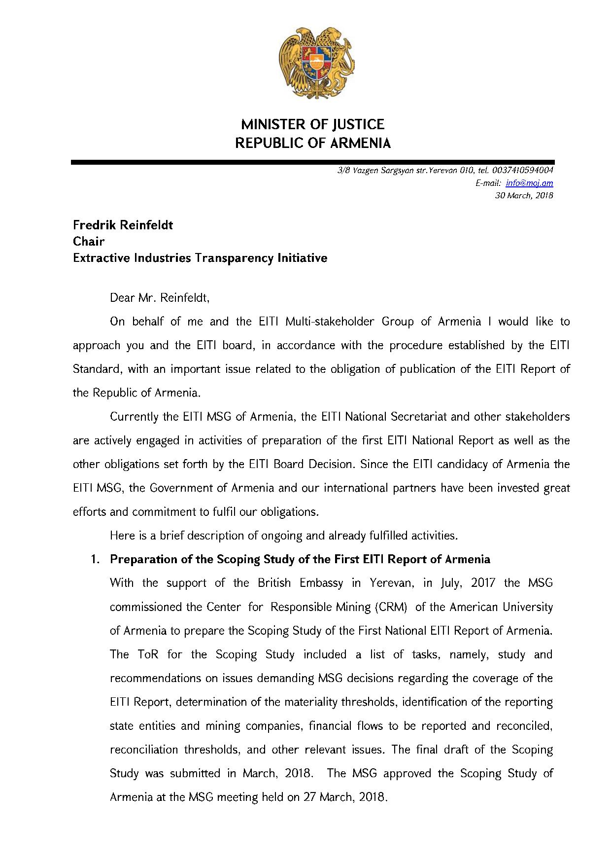
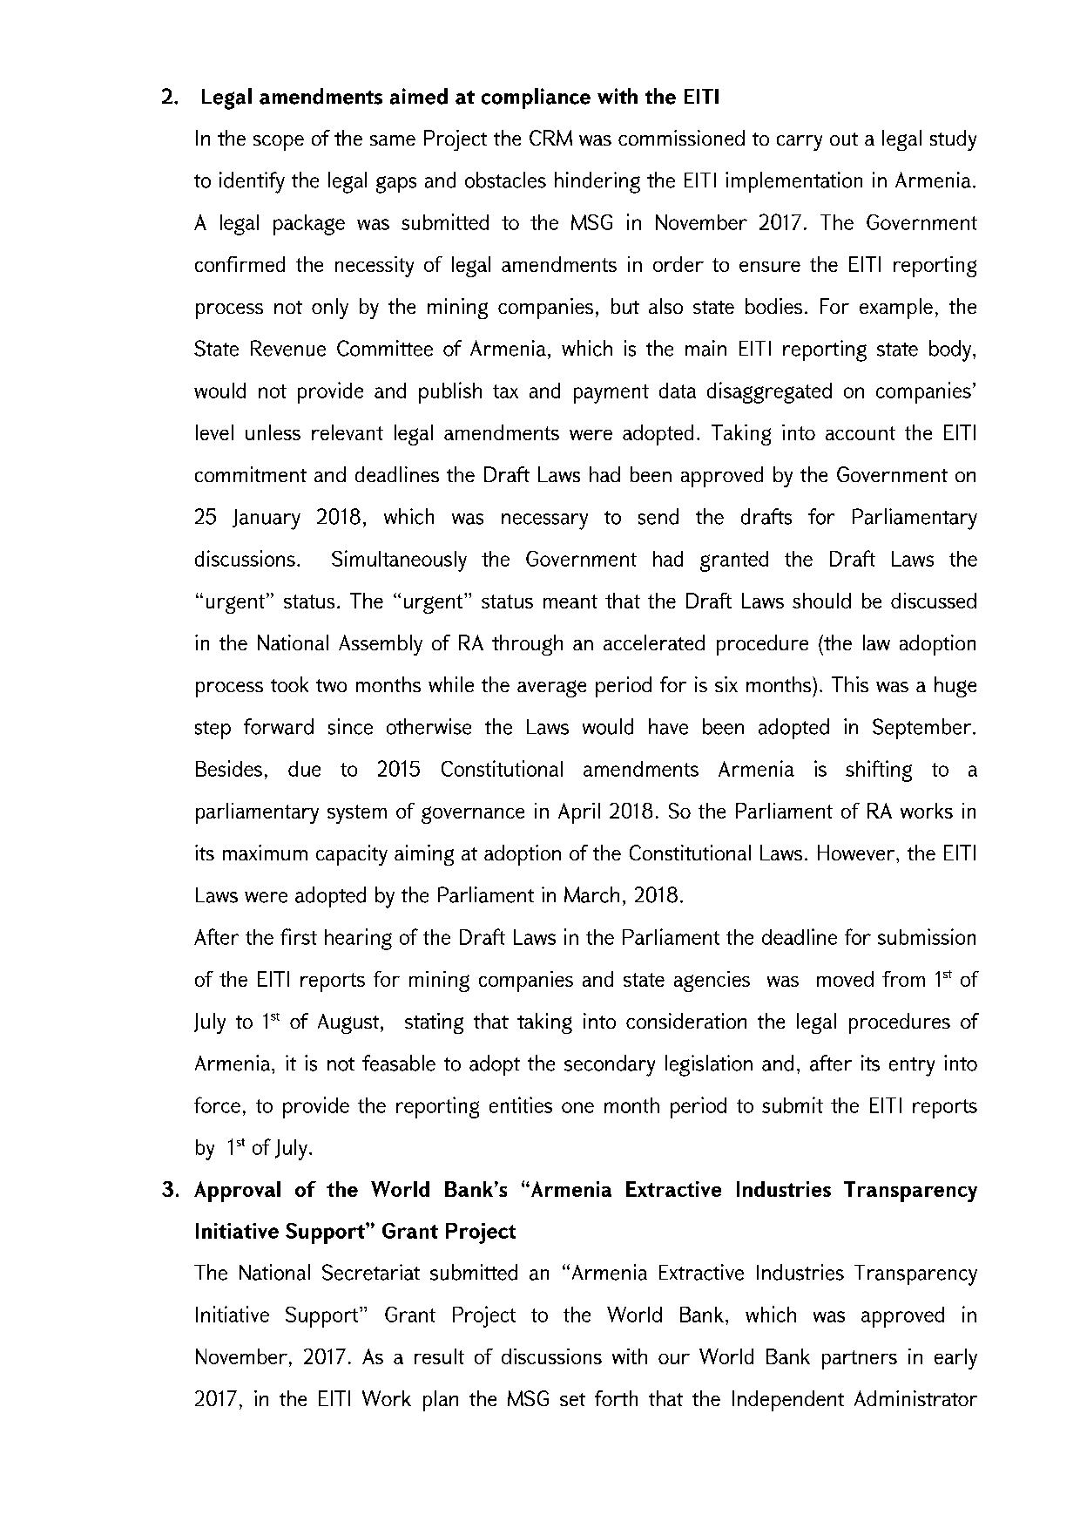
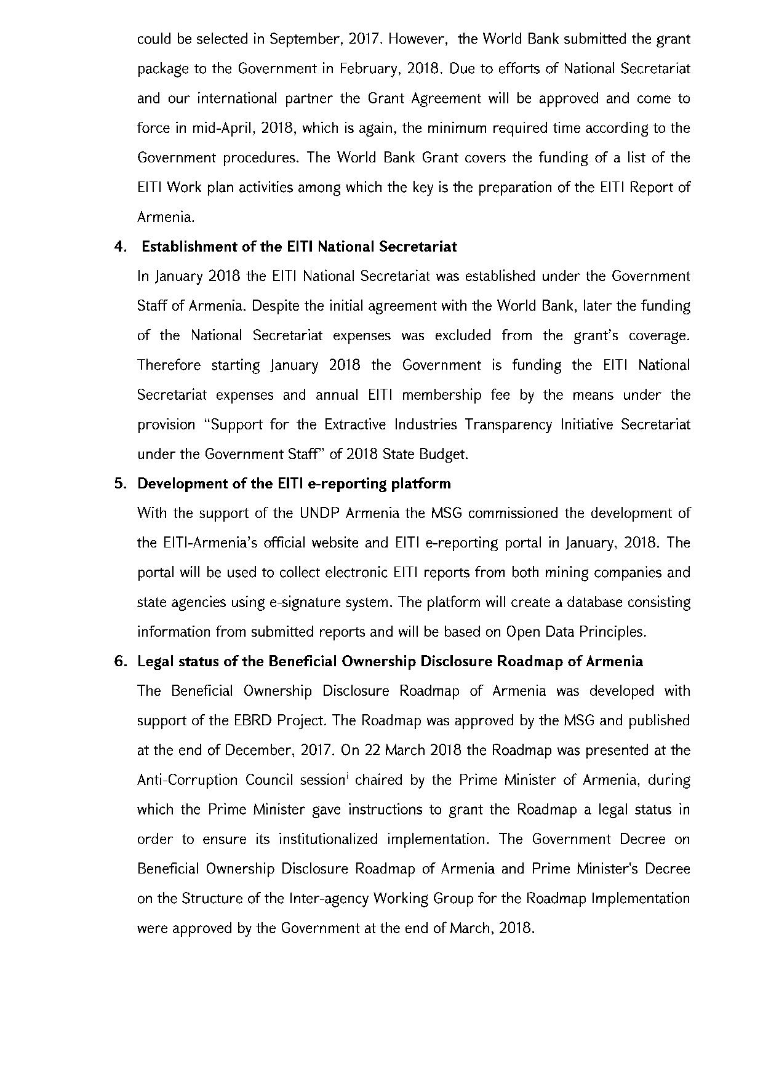
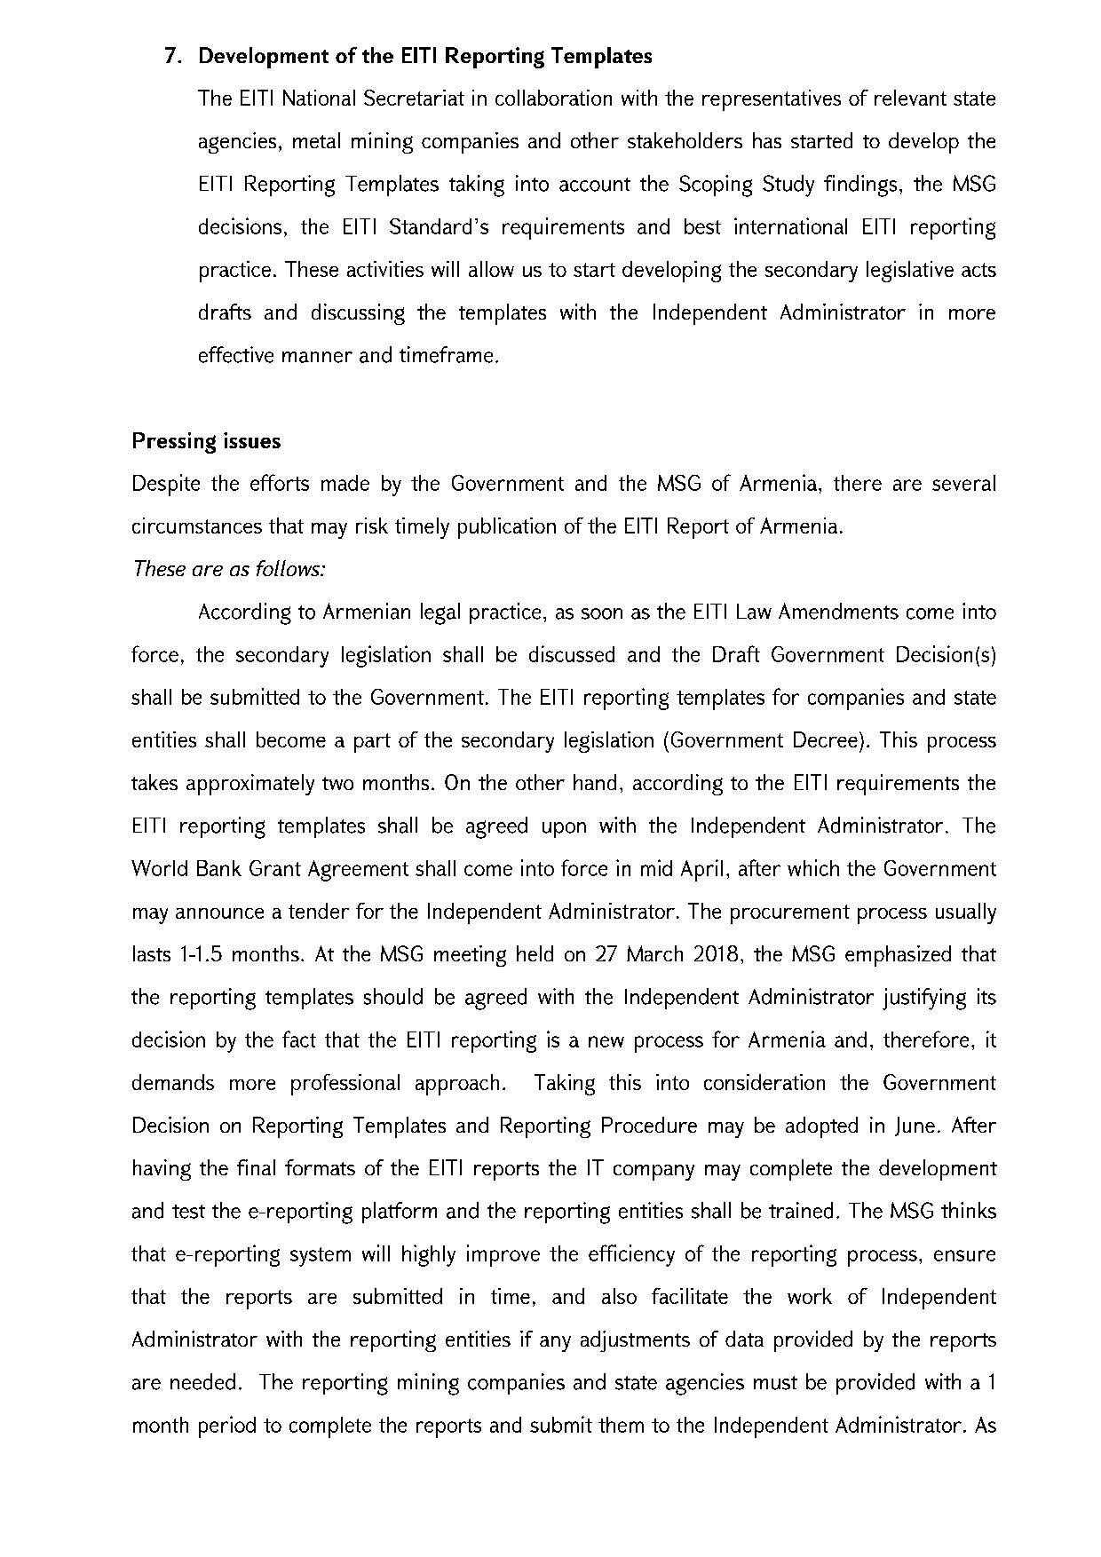
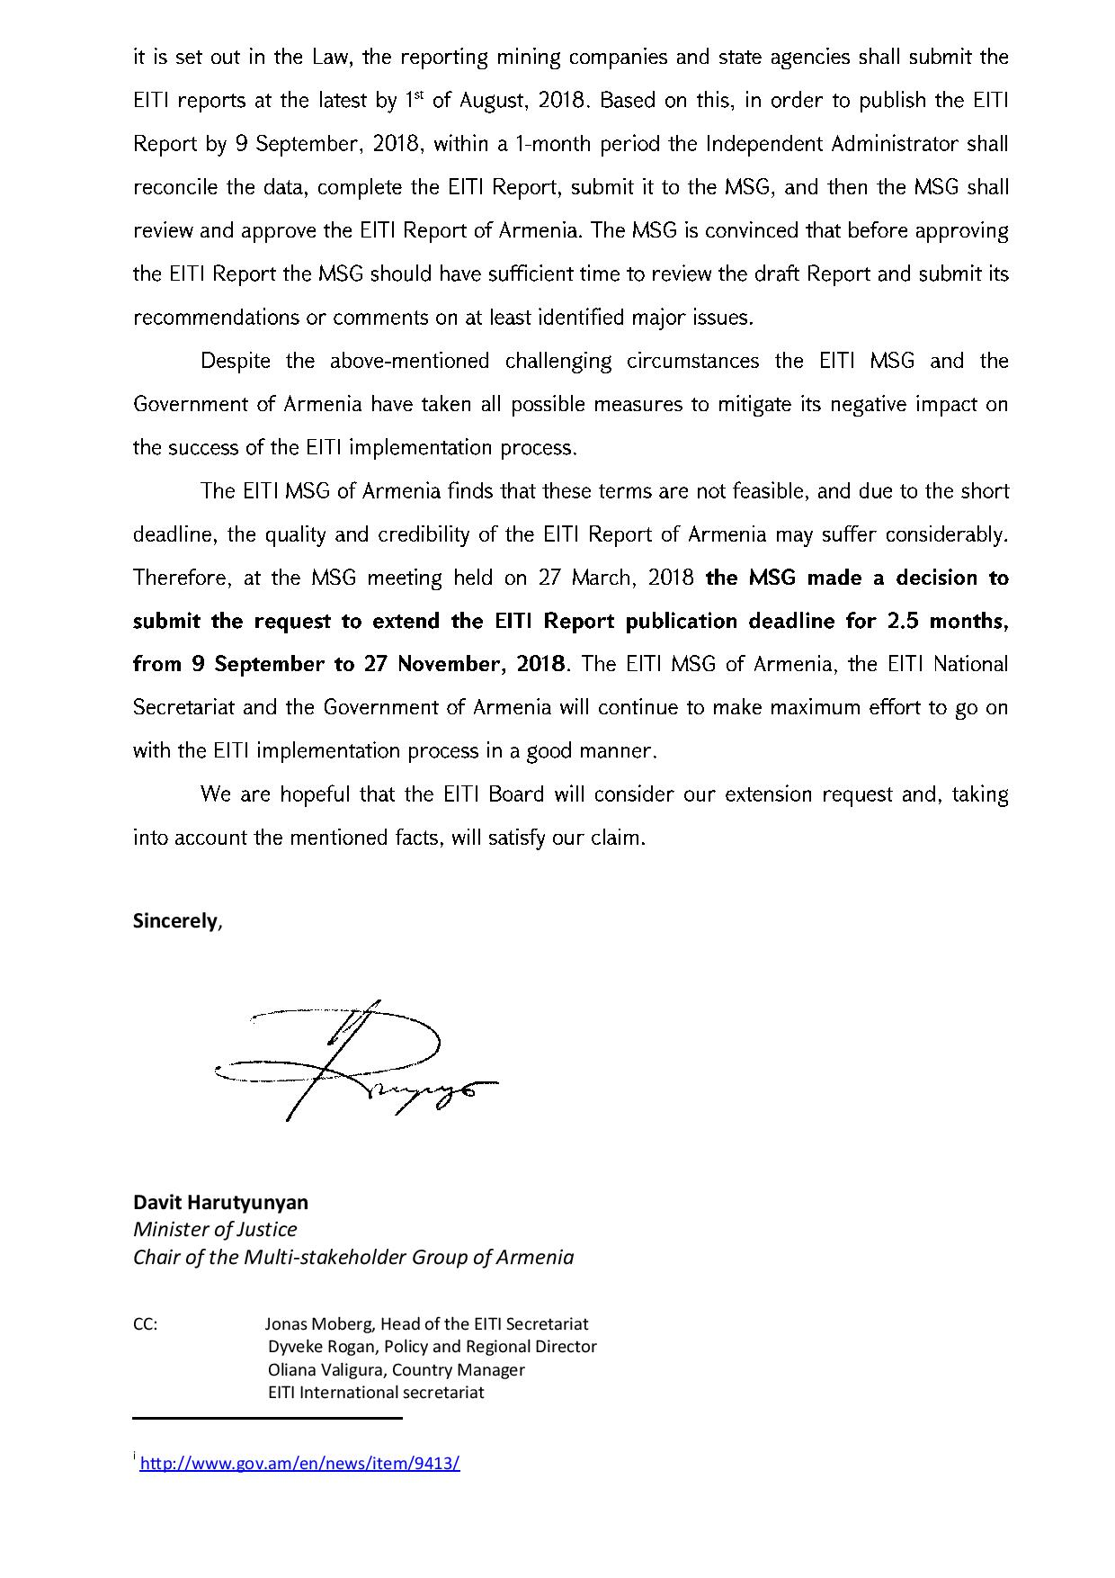
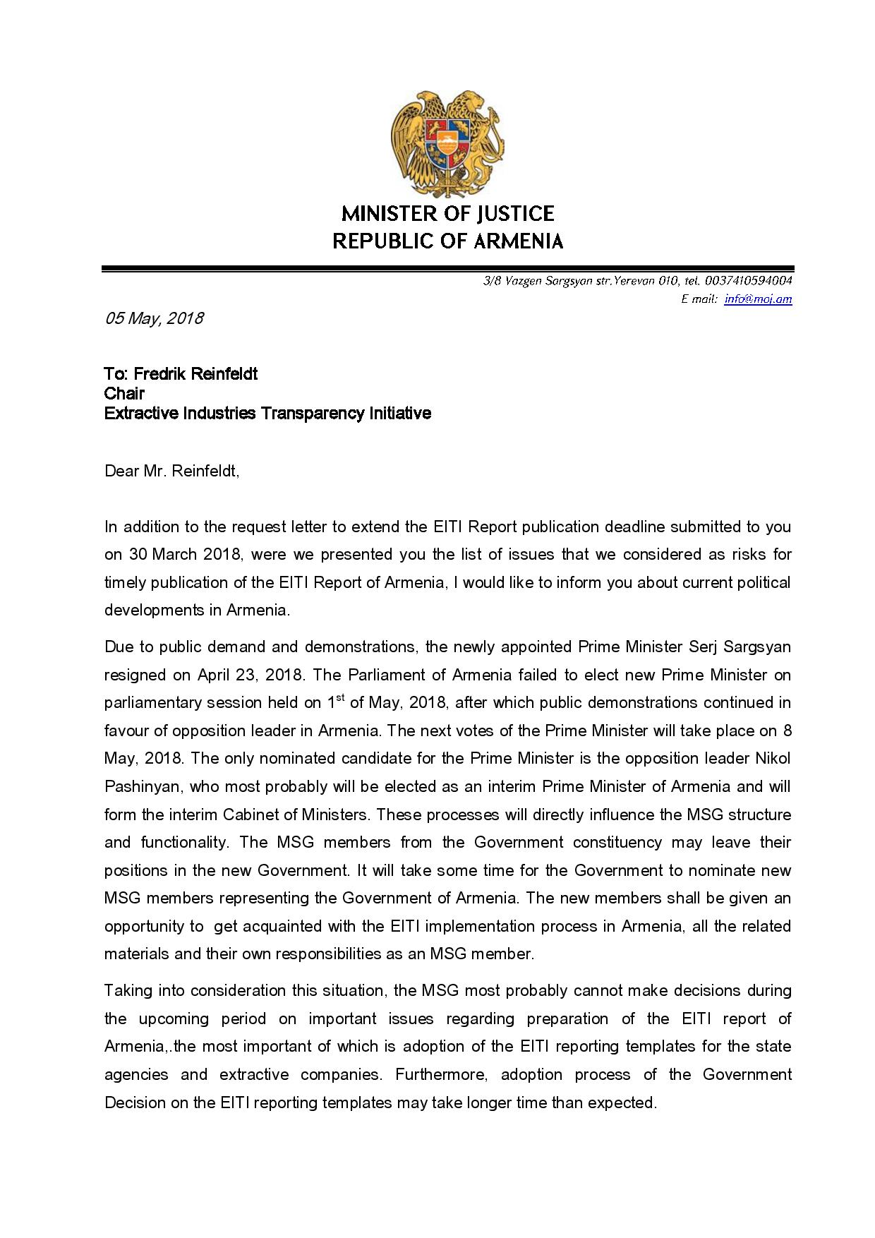
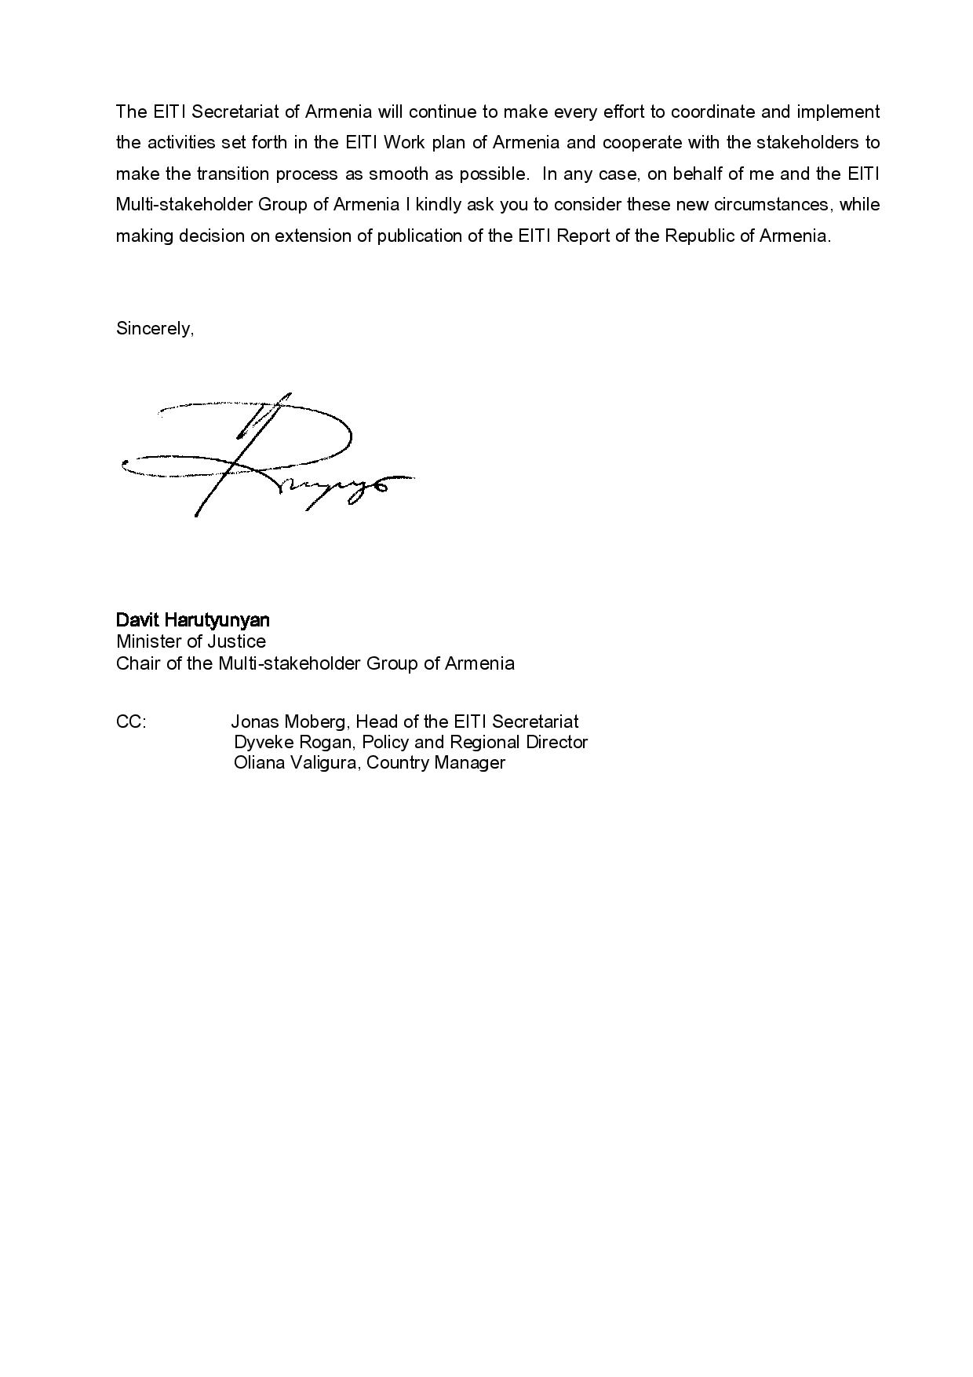
Annex 2
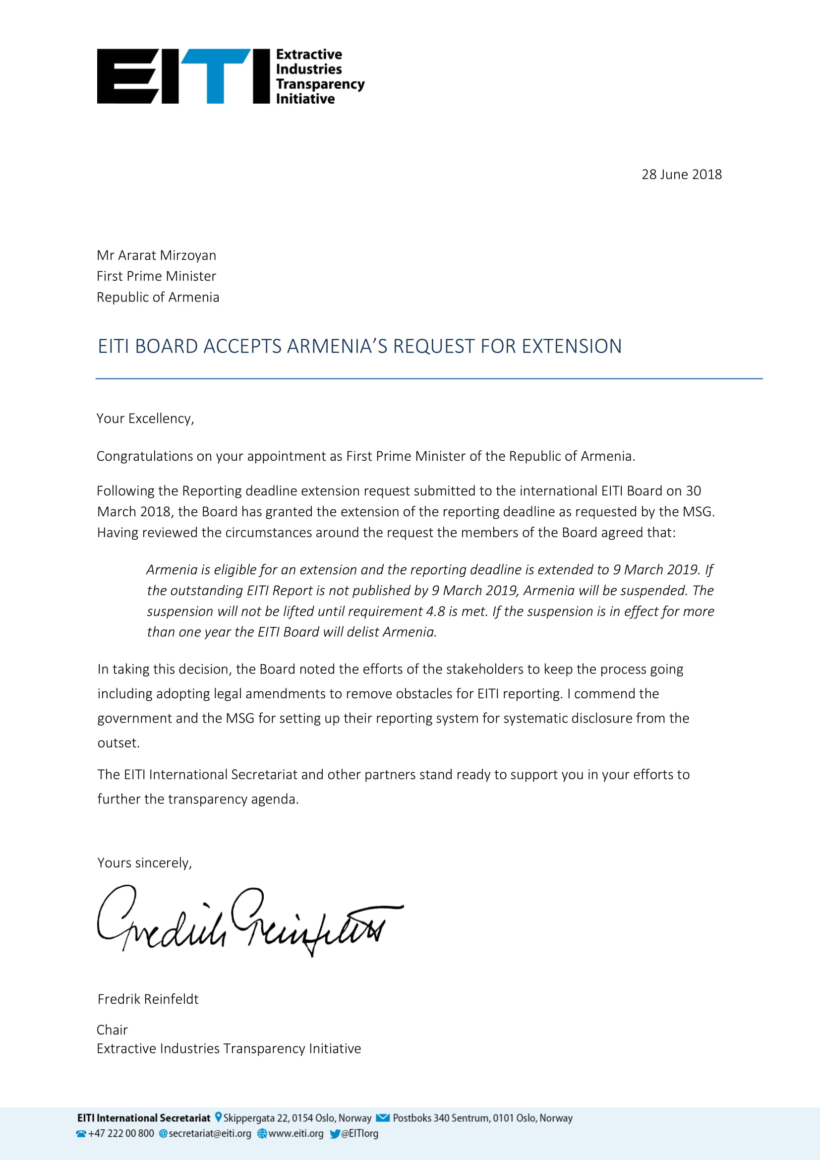

Annex 3
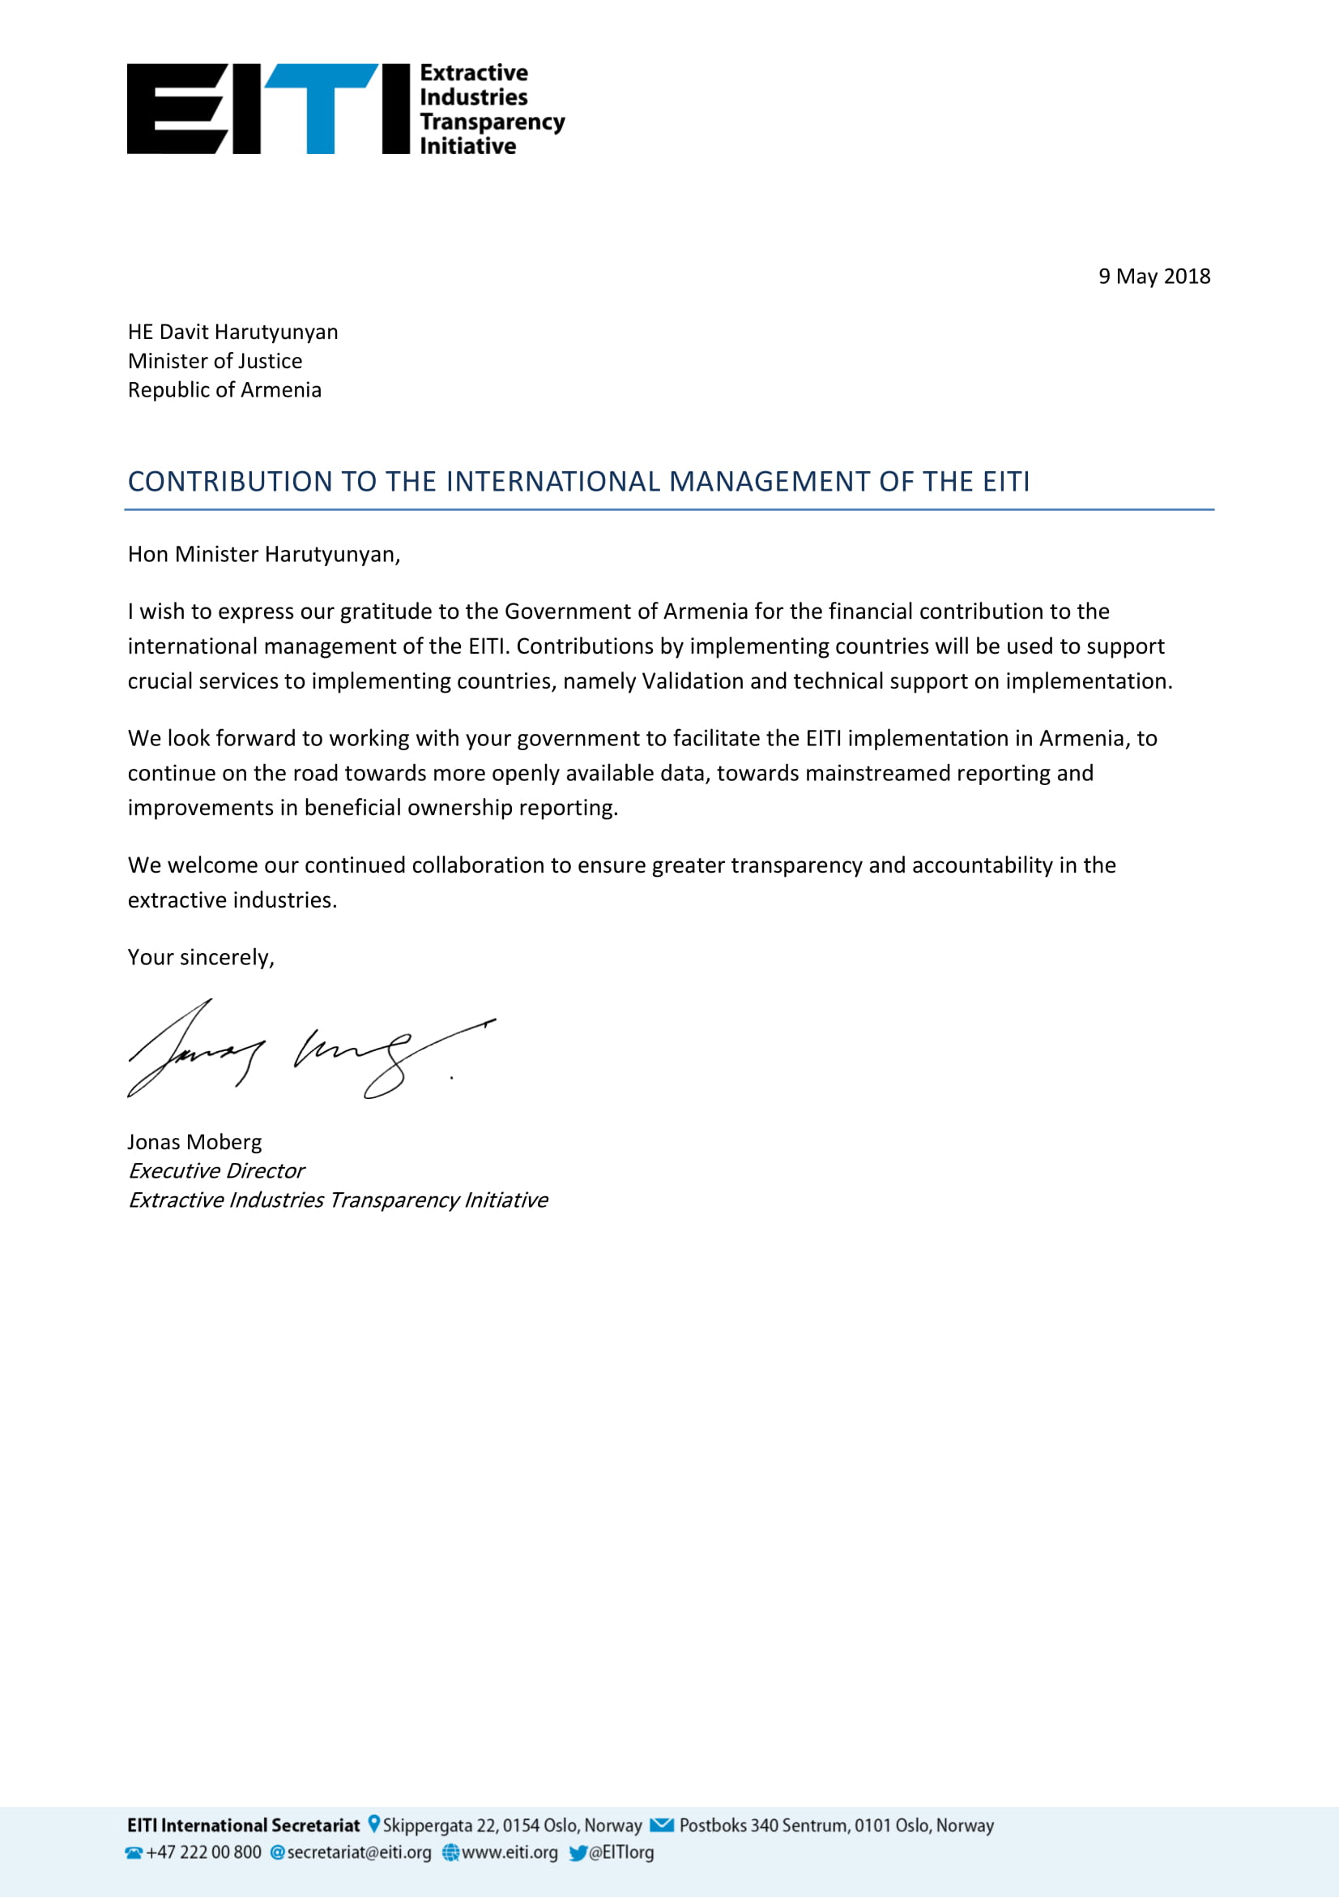

https://www.e-gov.am/decrees/item/18988/
https://www.arlis.am/DocumentView.aspx?DocID=120753
https://www.arlis.am/DocumentView.aspx?DocID=120539
https://www.arlis.am/DocumentView.aspx?DocID=120754
http://gov.am/am/eiti/
https://www.eiti.am/hy/
http://www.gov.am/u_files/file/ardyunaberakan-cragir/Annual_Progress_Report_2017.pdf
https://www.eiti.am/en/Quarterly-annual-reports/
https://www.eiti.am/en/agenda-protocols-other-related-documents
http://www.minenergy.am/page/571
http://www.minenergy.am/page/569
https://www.facebook.com/EITIArmenia/
https://www.youtube.com/channel/UCx_9yOLmQCj_rwy2wYgRh6A
https://twitter.com/EITI_Armenia
https://www.eiti.am/hy/%D5%A1%D5%B5%D5%AC
https://www.eiti.am/file_manager/e-reporting%20templates/EY_EITI_Instructions.pdf
https://www.eiti.am/hy/%D5%86%D5%B8%D6%80%D5%B8%D6%82%D5%A9%D5%B5%D5%B8%D6%82%D5%B6%D5%B6%D5%A5%D6%80/2018/12/05/2018/20/
http://www.arlis.am/DocumentView.aspx?DocID=121254
http://www.arlis.am/DocumentView.aspx?DocID=120899
https://www.eiti.am/hy/%D4%B2%D5%87%D4%BD-%D5%AB-%D5%A1%D5%B7%D5%AD%D5%A1%D5%BF%D5%A1%D5%B6%D6%84%D5%A1%D5%B5%D5%AB%D5%B6-%D5%AD%D5%B4%D5%A2%D5%A5%D6%80
https://www.e-draft.am/projects/1048
http://www.primeminister.am/hy/press-release/item/2018/10/10/Cabinet-meeting/
http://parliament.am/agenda.php?AgendaID=505&day=13&month=11&year=2018&lang=#13.11.2018
http://parliament.am/register.php?AgendaID=505&day=16&month=11&year=2018&lang=#16.11.2018
https://www.e-draft.am/projects/602
http://www.arlis.am/DocumentView.aspx?DocID=120753
http://www.arlis.am/DocumentView.aspx?DocID=120754
http://www.arlis.am/DocumentView.aspx?DocID=120539
https://www.e-draft.am/projects/602
https://www.eiti.am/hy/%D4%B2%D5%87%D4%BD-%D5%AB-%D5%A1%D5%B7%D5%AD%D5%A1%D5%BF%D5%A1%D5%B6%D6%84%D5%A1%D5%B5%D5%AB%D5%B6-%D5%AD%D5%B4%D5%A2%D5%A5%D6%80
https://www.eiti.am/en/other/
https://www.eiti.am/file_manager/EITI%20Documents/Minutes/Roadmap_Responsible_Mining.pdf
http://www.gov.am/u_files/file/ardyunaberakan-cragir/Annual_Progress_Report_2017.pdf
https://www.eiti.am/hy/%D4%B5%D5%BC%D5%A1%D5%B4%D5%BD%D5%B5%D5%A1%D5%AF%D5%A1%D5%B5%D5%AB%D5%B6-%D5%BF%D5%A1%D6%80%D5%A5%D5%AF%D5%A1%D5%B6-%D5%B0%D5%A1%D5%B7%D5%BE%D5%A5%D5%BF%D5%BE%D5%B8%D6%82%D5%A9%D5%B5%D5%B8%D6%82%D5%B6%D5%B6%D5%A5%D6%80
https://www.eiti.am/en/agenda-protocols-other-related-documents/
http://www.gov.am/u_files/file/ardyunaberakan-cragir/MSG_Quarterly_progress_report_October-December_2017.pdf
http://www.gov.am/u_files/file/ardyunaberakan-cragir/EITI_Workplan_Armenia_implementation_2017_arm.pdf
http://www.gov.am/u_files/file/ardyunaberakan-cragir/EITI_Workplan_Armenia_arm_2018_reviewed.pdf
https://www.eiti.am/hy/%D4%B1%D5%83%D4%B9%D5%86-%D5%A1%D5%B7%D5%AD%D5%A1%D5%BF%D5%A1%D5%B6%D6%84%D5%A1%D5%B5%D5%AB%D5%B6-%D5%AE%D6%80%D5%A1%D5%A3%D5%AB%D6%80
http://www.gov.am/am/armeniaeiti/
http://www.primeminister.am/hy/press-release/item/2018/10/10/Cabinet-meeting/
http://parliament.am/agenda.php?AgendaID=505&day=13&month=11&year=2018&lang=#13.11.2018
http://parliament.am/register.php?AgendaID=505&day=16&month=11&year=2018&lang=#16.11.2018
When completing the Section “Other Considerations”, it is recommended to be guided by the “Guidance note 5 on annual progress reports (APR)” at https://eiti.org/GN5

