January 21, 2021
Rena Guenduez
Toronto Canada
rguenduez@gmail.com
Formulating Effective Workplans
and Measuring Results in a
COVID-19 ERA
Workshop Toolkit

RBM Approach
Effective project management requires the focus of implementation to be on the actual results that are achieved, rather than on the various activities that are carried out in project implementation. RBM enables the definition of clearly articulated goals, objectives, and expected results, and provides tools to measure the progress towards achieving them.
RBM defines levels of desired results (outcomes and outputs), applies the indicators used to measure performance toward results, and explicitly monitors the risk factors that may affect their achievement. The RBM approach provides the framework and operational tools that enable a shared understanding among stakeholders of the vision, targets, and progress towards achieving its expected results.
There are four key elements of the RBM approach these are defined below.
Key Results Based Management Definitions
Logic Model (LM) | Vision | The LM ensures a clear link between investment (grant funds) and project results and assists in the roll-up of results for monitoring and reporting purposes.
Risk Register (RR) | Implementation and Planning | The risk register is a table that describes all significant risks that are identified as related to environmental conditions, stakeholder input and other influencing factors. Negative impacts can pose a risk for the success of your activities and overall actions or strategies. Therefore, risks need to be mitigated risks. As new risks emerge, new mitigation strategies will be developed. Not all risks are negative as some come with opportunities so identifying these is also important.
Work-breakdown Structure (WBS) | Activities and Outputs | The WBS is aligned with the Logic Model and is a breakdown of activities and the expected outputs that these activities will produce. These can range from tools to trainings and will support the achievement of immediate (short term objectives), intermediate (medium term objectives) and the ultimate outcomes (goal).
Project Management Framework  (PMF) | Monitoring and Reporting | The PMF takes into consideration qualitative and quantitative indicators for each result level, and a baseline for each indicator from which targets can then be established. Through the PMF, performance information will be gathered continuously. Rigorous analysis of the information provided through the PMF can alert project management to areas where corrective action might be needed if project strategies are not leading to expected results. All measured results can be used in the annual progress report and be presented as achievements of your member organization.

RBM Model

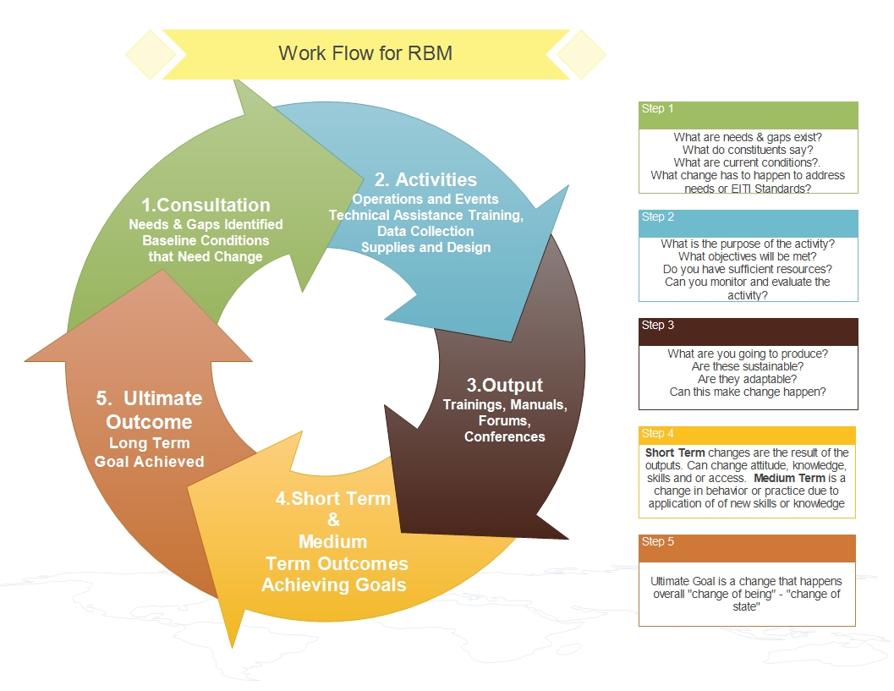

Impact and Effort
Sample Exercise to determine if you have all the resources required to make an activity viable.
Create a Relevant Activity:

Develop a plain language
Objective
Level of Impact | Short Term | Medium Term | Long Term | How Many People?
Level of Effort | Human Resources | Skills and Capacity | Finances | Time?
What will be produced/created or learnt?

ULTIMATE GOAL  Change of State |  | GOAL  Foster Improved Governance of the extractives sector by publishing robust data that generates public debate, builds capacity and empowers citizens to make knowledge-based decisions over the allocation of resources
MEDIUM TERM  Objective  Change of Performance |  | OUTCOMES
 |  | 1 |  |  |  |  |  |  | 2
SHORT TERM Objectives  (Change in Capacity) |  | 1.1 |  | 1.2 |  |  |  | 2.1 |  |  |  | 2.2
OUTPUTS  (Activity to Complete) |  | 1.1.0 |  | 1.2.0
 |  | 1.1.1 |  | 1.2.1

Work Breakdown Structure
ULTIMATE GOAL
GOAL
Foster Improved Governance of the extractives sector by publishing robust data that generates public debate, builds capacity and empowers citizens to make knowledge-based decisions over the allocation of resources
Intermediate Objectives | 1
Immediate Objectives | 1.1
Description of Planned and Proposed Activities

1.1.1 Output-
1.1.2
1.1.3
1.1.4

Risk Matrix
Sample
 | Risk Definition | Risk Response | Impact/Opportunity | High | Medium | Low
1 | COVID-19 may see another office shut-down in government if numbers increase. Access to partners and beneficiaries may be limited to technology platforms only. | Assess access to new technologies. Provide additional support for internet use. Use simple technologies and platforms to reach out to stakeholders | Opportunity to reach to a broader audience through technologies, not limiting participation | X
2
3
4
5
6
7
8
9

Project Management Framework
Sample
Identify an indicator that is measurable.

Expected results | Indicators | Baseline | Target | Data Sources | Data Collection Methods | Frequency | Responsible
Ultimate Outcome/Goal
Increased number of Citizens that are aware of the benefits of transparency and good governance in the Extractives Sector and have the knowledge and skills to lead and stimulate debate around key issues and advocate accordingly | Enhanced perception (%) of citizens feeling that EITI is performing its role in increasing | Feasibility Study | Direct and Indirect Stakeholders | Government reform, laws, and regulations | Survey, Interviews | Annually | EITI Member organization
Intermediate Outcome/Medium Term Objective
1  Improved ability to communicate and engage multiple stakeholders in discussions and increased awareness around natural resource allocation and sector transparency | Increased Awareness and Number of Number of Activities taking place | 2019 Annual Progress Report | Member Country MSG, Constituents Stakeholders | Annual Progress Report | Survey, Interviews, Platform tracking on social media | Quarterly | EITI Member organization
2

Immediate Outcomes/Short Term Objectives
1.1  Stakeholders have the knowledge and skills to lead and stimulate debate around sector transparency | Increased number of activities related to EITI by constituents | TBD | MSG Constituents CSOS, Industry | TBD | Social Media tracking, conferences and forums | Quarterly | EITI Member organization
2.1

Activity
1.1.1
2.1.1

