Mainstreaming
A toolkit for mainstreaming EITI disclosures

What is mainstreaming
Extractive industry transparency should not be confined to an EITI Report. Rather, it should become an integral part of how governments manage their extractive sector and companies manage their operations.
EITI implementing countries are increasingly making the information required by the EITI Standard available through government and corporate reporting systems. Information is now available through databases, websites, annual progress reports, portals etc., rather than relying on EITI Reports to bring about transparency.
This toolkit briefly explains what mainstreaming means in practice; it introduces a tool for assessing which disclosures are already mainstreamed, identifies some common challenges and provides some examples of how countries have mainstreamed some aspects of the EITI Standard.

Mainstreaming in practice
Mainstreaming EITI disclosures means that governments and company agencies integrate, or systematically disclose, information covered by EITI Requirements. When countries mainstream, EITI Reports are used as a tool to address gaps in information, if/when needed. EITI Reports can also be used to collate information from the primary sources, with a focus on making this information more understandable to the general public.
Systematic disclosure means that government agencies and companies - which would have otherwise provided information to an EITI Report through reporting templates - start providing these disclosures ‘at source’; in their own publications and websites.
In the EITI Standard, most of the ‘disclosure-requirements’ refer to publication in an EITI Report. But the definition of “EITI Report” is very broad, enabling mainstreaming: “The data [required by the EITI] can be disclosed in the form of an EITI Report, or constitute publicly available information and data gathered or cross-referenced as part of the EITI process” (EITI Standard, p. 12). This approach does not require approval from the EITI Board.
Reconciliation of revenues and payments by an Independent Administrators (IAs) is the exception, until the multi-stakeholder groups (MSGs) agrees that routine disclosure is performed in enough detail, and that it is subject to a “... credible, independent audit applying international standards …” (EITI Standard, p. 26). If so, the MSGs can apply to the EITI Board for also mainstreaming the final piece of information - the quality assurance of financial disclosures. This requires a feasibility study.
The disclosures required by the EITI Standard are summarised in both the Terms of Reference for a mainstreaming feasibility study, and in the ‘Mainstreaming tool’ presented below.

Mainstreaming tool
The mainstreaming tool is an excel file containing a list of all the required disclosures under the EITI Standard. It can be used to assess which disclosures are already made available to the public outside of the EITI process.
For MSGs and national secretariats, a useful question to ask when performing the exercise is …
“Our latest EITI Report covered fiscal year XXXX (e.g. 2015). Can I find the same information for XXXX+1 (i.e. 2016) already? What disclosures can I find without referencing to any EITI-related documents and websites?”
Once the information has been located, the mainstreaming tool assists in answering the following two questions (i) Are the disclosures commensurate with what is required by the EITI Standard? And (ii) what is missing to comply with the EITI Standard?
A more detailed explanation is included below.

For each EITI Requirement, explain...
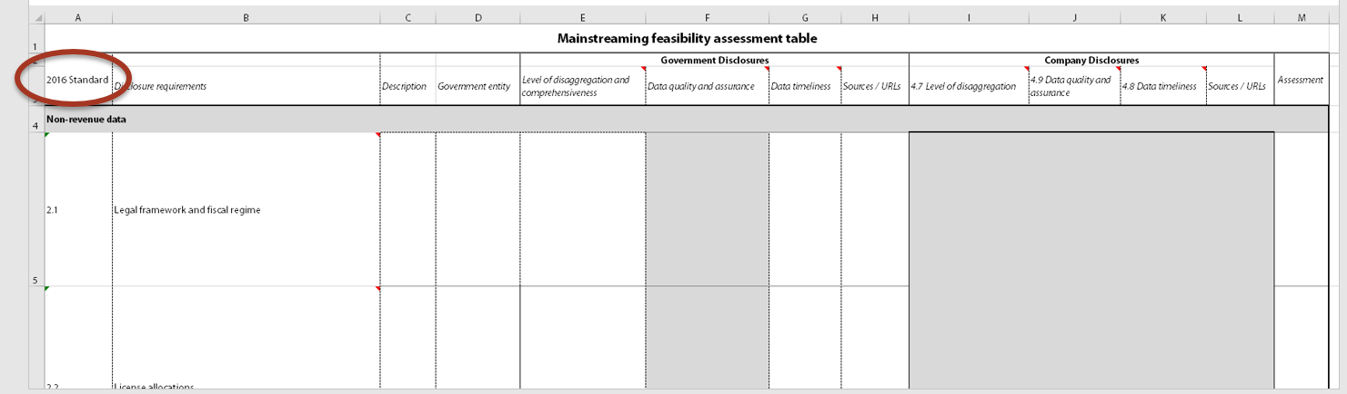

Step 1 – What is required to be disclosed in your country? (comments in cells list the requirements)
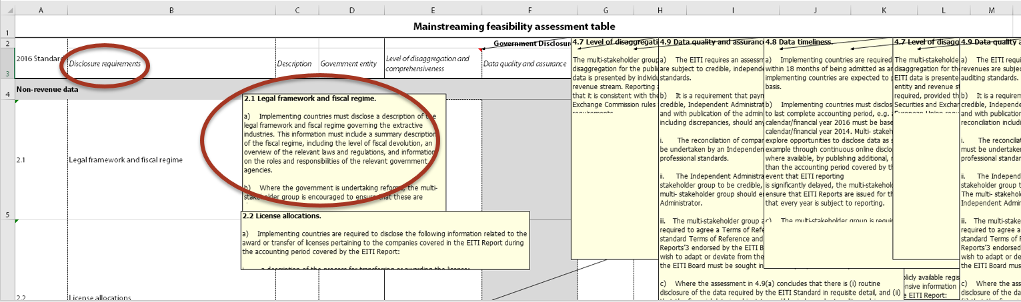

Step 2 – List what is disclosed and by what agency/company?
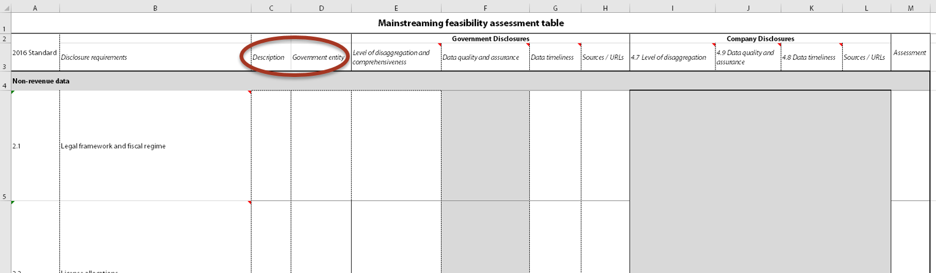

Step 3 – Then distinguish between government and companies, and assess/do the following:
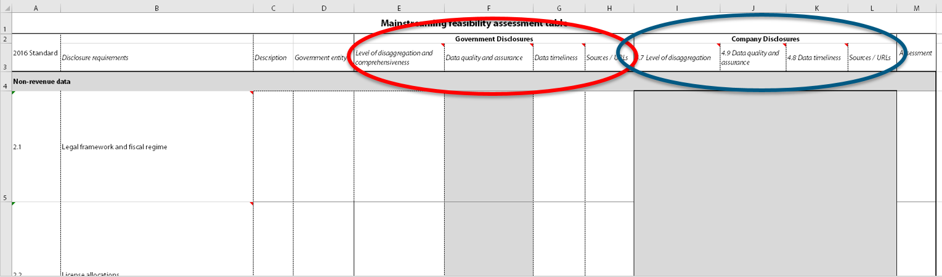

- Is the information comprehensive and detailed enough?
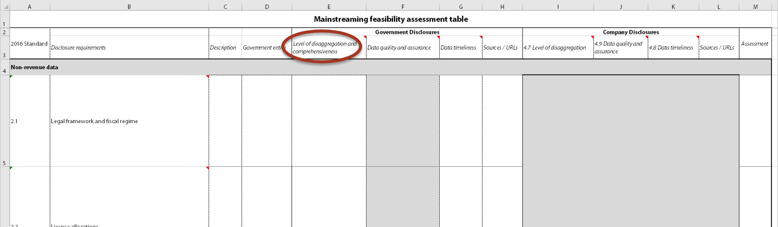

- Is the information reliable? Is it quality assured?
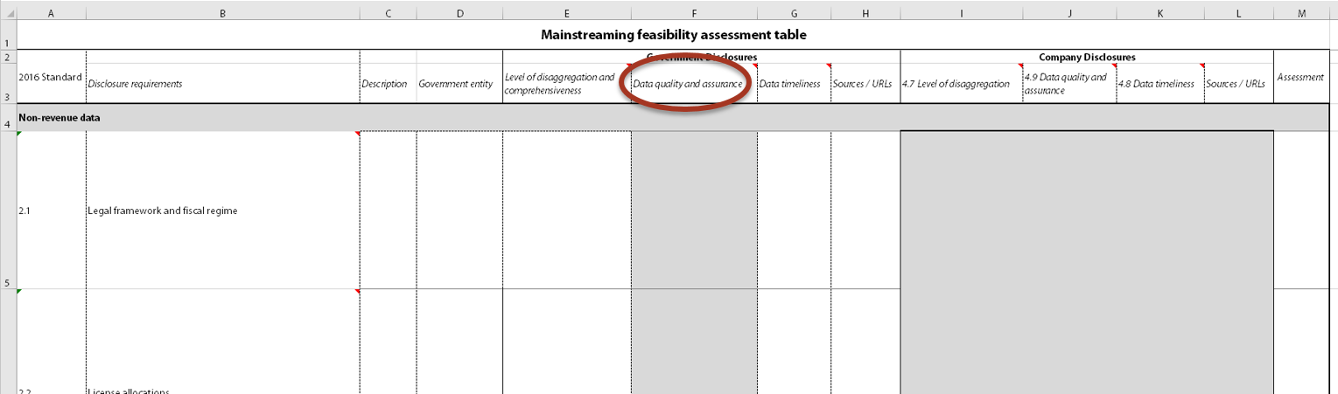

- How quickly and how often is it published and/or updated?
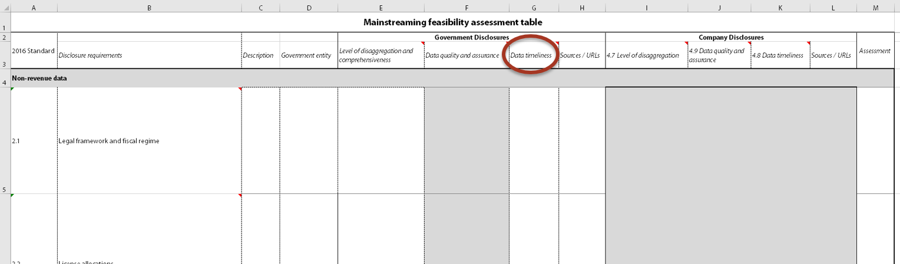

- Provide direct links to the information
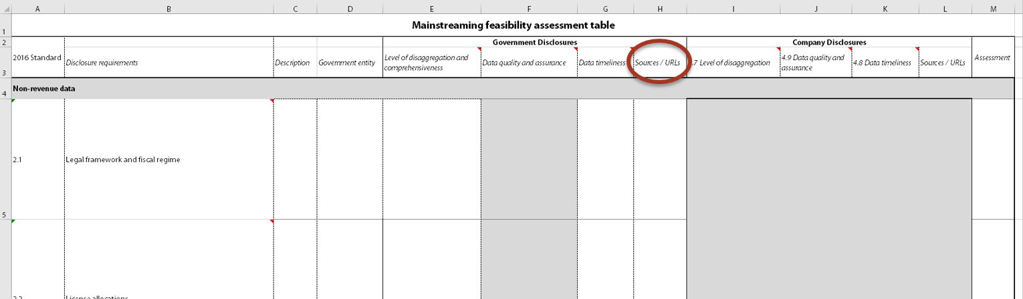

Step 4 – Assessment: What deviates from the EITI Standard? Where are the gaps?
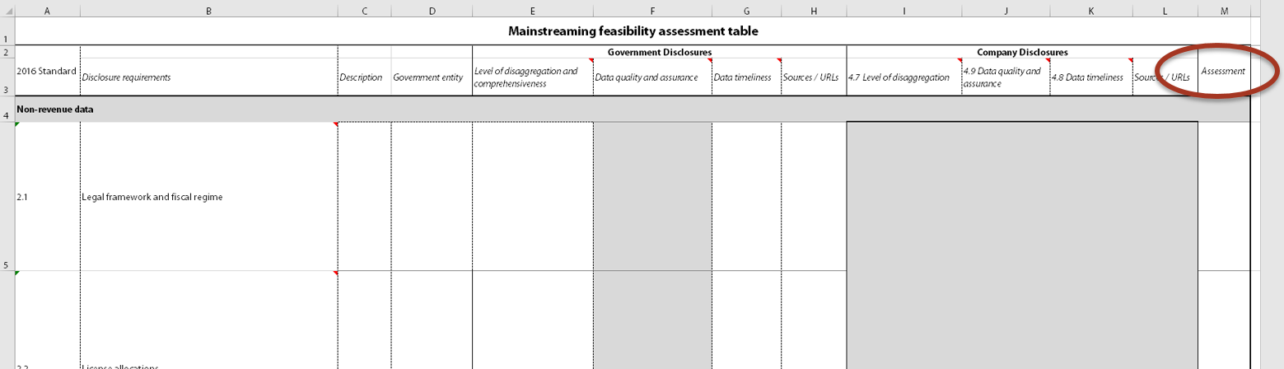

Step 5 – Make a plan for dealing with the missing information. Ask the International Secretariat for support if you have questions and/or need examples.

Country examples
Here we provide some examples of countries that have made progress in mainstreaming EITI disclosures. It is important to note that mainstreaming does not have to mean mainstreaming of all disclosures, but can be partial; enabling a step-by-step or requirement-by-requirement approach.

Norway
Norway has emerged as the first EITI country to apply and receive acceptance for a mainstreaming application. The government maintains a site called Norwegian Petroleum containing “Everything you need to know about Norwegian petroleum activities”. The portal provides most of the information required by the EITI Standard, including a wide array of maps and graphs ready for download. Upon the acceptance of the EITI Board, Norway has therefore replaced annual EITI Reports with systematic open data disclosures.

Kazakhstan and Mongolia - automated disclosures
An important step towards mainstreaming of company payments and government revenues is automated online disclosures. Both Kazakhstan and Mongolia have created or incorporated EITI disclosures into online platforms through which subsoil users (extractive companies) upload their data alongside their audit statements. In Kazakhstan, the EGSU portal (only in Russian/Kazakh) has enabled them to publish the most timely EITI data each year since its completion in 2014. According to the feasibility study results, the revenue data is even duplicated on several government websites. The main outstanding issue is transparency of SOEs and contract on barter and infrastructure agreements. All contracts are available on the EGSU portal, but not open to public. The government is considering next steps to transitioning to mainstreamed EITI disclosures.
Mongolia’s portal covers revenue receipts and payments and their portal has enabled consistent and timely disclosure of revenue-data for more than 1000 companies operating in the country. The data portal contains data on licenses - including geographical and spatial information - as well as production volumes and values. Users can choose whether the information is presented by company, license or district. All the information is available for download in open formats such as Excel, CSV or JSON files. Mongolia is currently exploring opportunities for mainstreaming several disclosures related to EITI, avoiding their inclusion in EITI Reports.

License registries and payments - Liberia and Sierra Leone
Some online solutions facilitate mainstreaming of EITI disclosures, especially if integrated into government agencies and properly updated and used. Liberia has followed Sierra Leone’s example and begun using a centralised cadastre system which lists the largest mining companies, linking unique companies to licenses and all payments directly related to the same licenses. Although this does not cover all payments and receipts covered by EITI reconciliation, it is a significant step towards transparency being the default feature of government systems.

Dominican Republic
It is important to highlight that mainstreaming is not only an option for long-time implementers of the EITI Standard. Dominican Republic (EITI-RD) published their first ‘EITI Report’ in October, taking advantage of the broad definition of EITI Reports and disclosures. In EITI-RD, their website is the EITI Report. Instead of producing large physical copies of EITI Reports, all the necessary disclosures are made online as the default, while a reconciliation report is published as an ‘attachment’. This is a great example that reconciliation is the only work strictly requiring an independent administrator.

Support on mainstreaming
The International Secretariat provides advice and support to implementing countries considering mainstreaming.
For further information, contact Sam Bartlett (sbartlett@eiti.org) or Christoffer Claussen (cclaussen@eiti.org).

Mainstreaming tool: https://eiti.org/document/mainstreaming-mapping-exercise

