MODEL TERMS OF REFERENCE FOR AN EITI MULTI-STAKEHOLDER GROUP
Contents

1 Open statement on the purpose of the EITI 2
2 Roles, rights and responsibilities of the MSG 2
2.1 Responsibilities and functions of the MSG 2
2.2 Responsibilities of MSG members 2
2.3 MSG subgroups 2
2.4 National secretariat 3
2.5 Code of conduct 3
2.6 Payments 4
3 MSG membership 4
3.1 Nominations and terms of membership 4
3.2 Observers 5
4 MSG operations and proceedings 5
4.1 Frequency and notice of meetings 5
4.2 Decision-making 6
4.3 Record keeping 6

1 Open statement on the purpose of the EITI
[The MSG may wish to open the ToR with agreed principles setting out the purpose and objectives of the EITI in the country.]

2 Roles, rights and responsibilities of the MSG
[It is important to clarify the roles, rights and responsibilities of the MSG to ensure that the MSG has a clear mandate and to avoid confusion and overlaps. Requirement 1.4(b)(i-iii) set out the responsibilities of the MSG that should be reflected in the ToR.]

2.1 Responsibilities and functions of the MSG
[The MSG should specify the functions and responsibilities of the MSG. In accordance with requirement 1.4(b), this should include but not necessarily be limited to (i) approval of work plans; (ii) oversight of the EITI reporting process, including the appointment and approval of the Terms of Reference of the Independent Administrator, and endorsement of the EITI Reports; (iii) development of annual activity reports; (iv) the role of the MSG in the Validation process; (v) outreach and liaison with constituency groups; and (vi) communication activities.]
Example:
Stakeholder-specific working groups can be established to liaise with constituencies.
The MoU of the Papua New Guinea MSG states that “the Government of Papua New Guinea maintains the State Working Group (SWG) that is chaired by the Ministry of Treasury representative. In turn, the PNG Chamber of Mines and Petroleum Executive Director is the chair for the industry working group (IWG) with Transparency International PNG chairing the civil society working group (CSWG).”

2.2 Responsibilities of MSG members
[The MSG may wish to define the specific role of MSG members, e.g. the Chair. If constituencies have different responsibilities, these can also be defined here. If necessary, the MSG may wish to address capacity issues related to meeting responsibilities.]

2.3 MSG subgroups
[Many implementing countries have established MSG subgroups to handle specific tasks that the MSG needs to carry out, for example related to EITI reporting or communications. This can be an efficient way for ensuring that progress in made in between MSG meetings. The MSG may wish to specify whether permanent subgroups should be established, including their roles and responsibilities, or whether the ToR should provide for establishment of subgroups on an ad hoc basis.]

Examples:
The ToR of the UK EITI MSG states that the MSG may decide that particular issues should be developed by a sub-group. Each such sub-group must be led by an MSG member who will be supported by one or more other MSG members. . The sub-group leader may also invite outside experts to participate in the sub-group, but only with the agreement of all MSG sub-group members. The subgroup makes recommendations to the MSG.
According to the NEITI Board Charter, the MSG in Nigeria has six Standing Committees: Audit and Risk Committee, Human Resource Committee, Finance and General Purpose Committee, Communications Committee, Board Tender Committee and Ethics Committee. Ad hoc Committees can be established as the need arises.

2.4 National secretariat
[Most implementing countries decide to establish a national EITI secretariat to support the work of the MSG and be responsible for the day-to-day EITI activities. The MSG may wish to define the MSG’s relationship with the national secretariat, including the roles and responsibilities.]
Example:
The ToR of the Philippines EITI MSG states that the MSG supervises the National Secretariat. In Nigeria, the Executive Secretary is appointed by the President on recommendation from the MSG and is also a full member of the MSG.

2.5 Code of conduct
[The MSG may wish to include guidelines on the conduct of MSG members. This typically includes disclosure of conflicts of interest, treatment of confidential information, etc.]

2.6 Payments to MSG members
[Where the MSG has a practrive of per diem for attending EITI meetings or other payments to MSG members, this practice should be transparent and should not create conflict of interest. (requirement 1.4.b.vi.)]
Examples:
According to the ToR of the Solomong Islands EITI MSG, a sitting allowance of SBD 300 should be paid to members of the MSG attending each meeting.
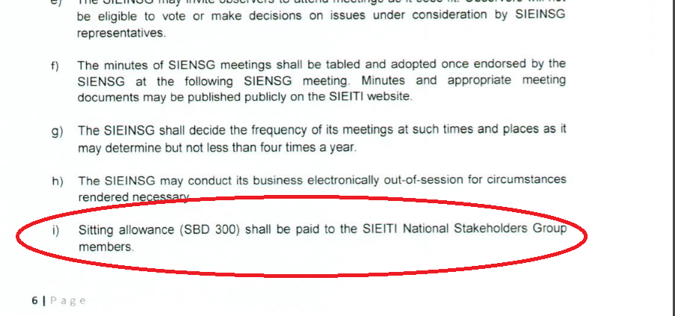

3 MSG membership
[The multi-stakeholder group should agree procedures for nominating and changing multi-stakeholder group representatives and the duration of the mandate (requirement 1.4.b.vi). In accordance with requirement 1.4.a, each stakeholder group must have the right to appoint its own representatives and be adequately represented. This does not mean that there must be an equal number of members from each constituency. ]

3.1 Nominations and terms of membership
[The MSG is advised to specify the total number of MSG members and the number of members from each constituency. It is required that the ToR clarifies (i) the mechanism for selecting and replacing MSG members; and (ii) determine the length of the term of the MSG and whether members can be re-appointed after the term ends; and (iii) specify whether MSG member have alternates and how they are selected.]
Examples:
According to the ToR of the Philippines EITI MSG, each constituency group can change their members according to their own governance rules.
Term lengths vary from country to country. A typical MSG term is two to three years (e.g. Indonesia, the Philippines, and Timor-Leste).
MSGs typically have 12 to 24 members. Several countries have equal numerical representation (e.g. Mongolia or Kazakhstan) while others have unequal numerical representation (e.g. Cameroon or Nigeria).

3.2 Observers
[The MSG may wish to specify a policy on observers.]

Examples:
According to the ToR of the Mongolia EITI MSG, “Citizens, representatives of national and foreign agencies and organizations are entitled to participate in the MSWG meeting, make speech, make proposal, ask questions and get responses.”
The UK EITI MSG ToR states that up to 6 observers will be welcomed at each meeting; they will be able to engage in the discussion at the MSG but will not have a right to vote. Observers for each meeting will be nominated by MSG members in advance of the relevant meeting. An additional standing observer slot will be allocated to the EITI International Secretariat

4 MSG operations and proceedings
[The MSG ToR should set out the internal governance rules and procedures of the MSG (requirement 1.4.b.(vi-viii).]

4.1 Frequency and notice of meetings
[Requirement 1.4(b)(vii) states that there should be sufficient advance notice of meetings and timely circulation of documents prior to their debate and proposed adoption. This enables MSG members to prepare for meetings and discussions. Any member of the MSG has the right to table an issue for discussion (requirement 1.4.(b)(vi)). The MSG is advised to ensure that the ToR specify the minimum notice of meetings, the frequency of meetings and the process for calling meetings.]

Examples:
The ToR of the Philippine MSG states that the MSG should meet quarterly or as often as required, with the Chair calling meetings, with a minimum of one week’s notice.
In Mongolia, the Chair and the Deputy Chair in the first instance have powers to call meetings, with the Secretary of the National Council given the responsibility to prepare for the meetings. The agenda and associated materials must be sent to all members at least 3 days before each National Council meeting.

4.2 Decision-making
[The EITI Standard requires an inclusive decision-making process throughout implementation, with each constituency being treated as a partner (requirement 1.4(b)(vi)). The ToR should specify the agreed procedures for decision making. This could include guidelines on quorum, voting rules, and procedures for decision-making in between MSG meetings.]
Examples:
Articles of Association of the EITI: “The Members’ Meeting shall make every effort to adopt resolutions by consensus. If a vote is required, resolutions are adopted by qualified majority requiring the support of at least two thirds of the total votes cast and must include the support of at least one third of the votes cast by the Members. representing each Constituency.”

4.3 Record keeping
[According to requirement 1.4(b)(viii), the multi-stakeholder group must keep written records of its discussions and decisions. It is recommended that the MSG ToR clarify the procedures for circulating and agreeing MSG meeting minutes, and whether the minutes should be made public.]
Example:
The meeting minutes of the Ukraine EITI MSG are made public after review by the MSG members.

