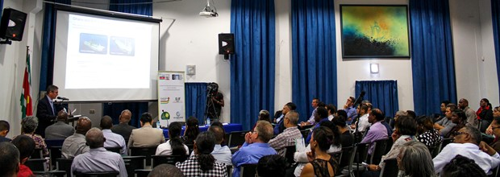

MINISTRY OF nr HOlds EITI-SYMPOSIUM
02-05-2016
Ministry of NR holds EITI-symposium
On 29 April the Ministry of Natural Resources (NR) held an Extractive Industries Transparency Initiative (EITI) symposium regarding our country’s application for the candidate status within this standards organization. The purpose of this activity was to inform as many actors directly and indirectly involved in the mining and petroleum sector in Suriname about the usefulness and importance of the EITI, the process of becoming a candidate and the implementation of the EITI standards.
According to the Minister of NR, Regilio Dodson, Suriname is at a crossroad in the mining sector and the Government is aware of the fair use of the natural resources for the development of our country. The Minister also said that he has an important role to play, when it comes to the natural resources of Suriname. ' The Ministry of NR has a mission to fulfill and I have committed myself to see to it that our natural resources are indeed implemented for the development of Suriname; After all we are a nation that strongly depends on the mining sector', Dodson stressed.
Transparency and "Public Statement"
During his speech the NR high official portrayed that the time is right enough for Suriname to directly work on transparency and coordination of the mining industry and financial policy. The introduction of the EITI standards requires that all transactions, which are carried out in the sector should be as transparent as possible and should be made public. 'Compliance with the EITI standards will entail that openness will be created both by the Government and the companies', Dodson said.
In countries that have committed themselves to the EITI standards, through publications it is shown what companies are paying the Government (in the form of, i.a. taxes and royalties) and what the Government is receiving from these companies. In addition to the revenues and expenditures, the reports also include information on licenses and contracts, government stocks, production statistics, income and investment spending. The NR-minister also took the opportunity to publicly announce (' public statement ') that Suriname intends to commit to the EITI standards.
Multi-stakeholders Group
In the context of the application of Suriname for EITI candidate status, the Ministry has set out a plan. These steps will have to result in a Multi-stakeholders Group (MSG). The installation of this independent Commission (the so-called Multi-Stakeholders Group) in which the Government, the private sector and civil society should be represented, is one of the most important requirements for obtaining of the EITI candidate status.
"The proposal is that the MSG comprises of nine person , namelys: three government representatives, three representatives of the civil society and three representatives of the companies', explained the NR-Director, Dave Abeleven. The MSG is expected to present a work plan on how the standards will be implemented.
On 17 June 2016 the Ministry will organize the first MSG Workshop. During this meeting, the proposals concerning the Term of Reference of the MSG, the Memorandum Of Understanding between stakeholders and the State and the representatives of each key stakeholder (government, companies and civil society) in the MSG as well as the processes will be discussed. The second planned MSG Workshop is on 5 August and will have to result in finalizing the Term of Reference, the Memorandum Of Understanding and the contours of the MSG. Organizing a National EITI-conference on 7 October is planned as well, aiming at installing the MSG and officially announcing that the application of Suriname’s candidacy will be submitted to the EITI Board.

